

KPI Thai Politics Up-date

No. 4 (February 6, 2008)

Constitution Referendum in Thailand:
Observations from Chachoengsao Province

Michael H. Nelson

In my first “letter from the field” posted on the New Mandala blog, dated July 23, 2007, I wrote, “I have not seen any banners or billboards pointing to the upcoming referendum. From public appearances, one would never know that there will be a referendum on August 19. In the office of the editor of a local newspaper, the two booklets of the draft constitution used for public hearings were still on the shelf. She knew that there would be a referendum, but she could not say when it would be held.” When I went to the municipality of Ko Khanun in Phanom Sarakham district with officials of the office of the Provincial Election Commission on July 20, campaign signboards and posters for the local election on August 5 were ubiquitous. Nothing pointed to the referendum to take place just a month later. A shopkeeper who I talked to had heard about the referendum, but she could not say when it would take place. The run-up to the referendum could not be compared to general elections, in which candidates place innumerable banners, posters, and cutouts everywhere, and personally distribute their election documents to voters, thus building their awareness of the event over many weeks. Rather, the referendum campaign was a quiet and low-key affair.
In this paper, I will describe the work of the Constitution Drafting Assembly’s (CDA) provincial-level “Extraordinary Committee for Public Hearings and People’s Participation,” anti-constitution activities, and the administration of the referendum by the provincial election commission (PEC). I will also relate opinions expressed by ordinary people about the constitution and the referendum and report the result of the vote.

The “Extraordinary Committee for Public Hearings and People’s Participation”

The referendum campaign constituted the third phase in the work of the CDA’s provincial branches, called “Extraordinary Committee for Public Hearings and People’s Participation.” The first phase concerned the collection of public opinions before the CDA prepared the first version of the draft constitution, while the second phase consisted of conducting public hearings on the first draft before it was subjected to revision.
The committee’s “Action plan regarding activities to publicize the draft constitution for the referendum (period 3)” of main promotional activities comprised 31 events between July 12 and August 15, 2007, as follows (the figures in brackets indicate the projected number of participants).

- One presentation at the monthly meeting of section chiefs with the provincial governor etc. in the provincial hall (sala klang) (50 people).
- Eleven talks at the equivalent meetings in the ten districts and one semi-district of the province (between 120 and 500 participants, depending on the size of the district, consisting mainly of sub-district and village headmen, and local government officials).
- Two stops at the monthly meetings of the provincial chamber of commerce and industry, respectively (50 each).
- Three appearances at trainings for community leaders in three sub-districts of Plaeng Yao district (50 participants each).
- Provincial disaster relief unit (200).
- Three presentations for school administrators (600, 200, 600; education district 1 is mentioned twice, with two different meeting places).
- Two appearances at the meetings of the association of Tambon Administrative Organizations (TAO) (40 people) and the association of palat TAO (80).
- Opening of a tambon-level learning center in Bang Nam Prioew district (200).
- Meeting of the provincial security and peace and order committee (150).
- Presentation at the provincial police station (300).
- Informational event at the office of Chachoengsao municipality for representatives from its communities (100).
- Student meeting at the Rajaphat University (1,000).
- One labor-related event at the open multi-purpose hall (called sala thai) opposite of the provincial hall (100).
- One visit to the Bang Pakong power plant on the request of its staff members (150).
- One meeting with local media representatives (100).

As one can easily see, only a tiny fraction of voters in Chachoengsao could be reached by these activities, given that the province had 477,492 registered voters. However, since the very limited budget did not allow a broadly-based publicity campaign, the committee targeted various groups of multipliers rather than individual voters. The number of actual participants was often lower than the projected number. Moreover, the durations of the events as given in the action plan were completely unrealistic. For example, the eleven district meetings were said to last from 0900 to 1200 hours. From this one might have expected to see a very thorough introduction to the draft constitution by the provincial branch of the CDA. In fact, however, these meetings were regular monthly events, and the committee had merely asked to be given about 30 minutes to tell participants briefly why the draft constitution should be accepted.

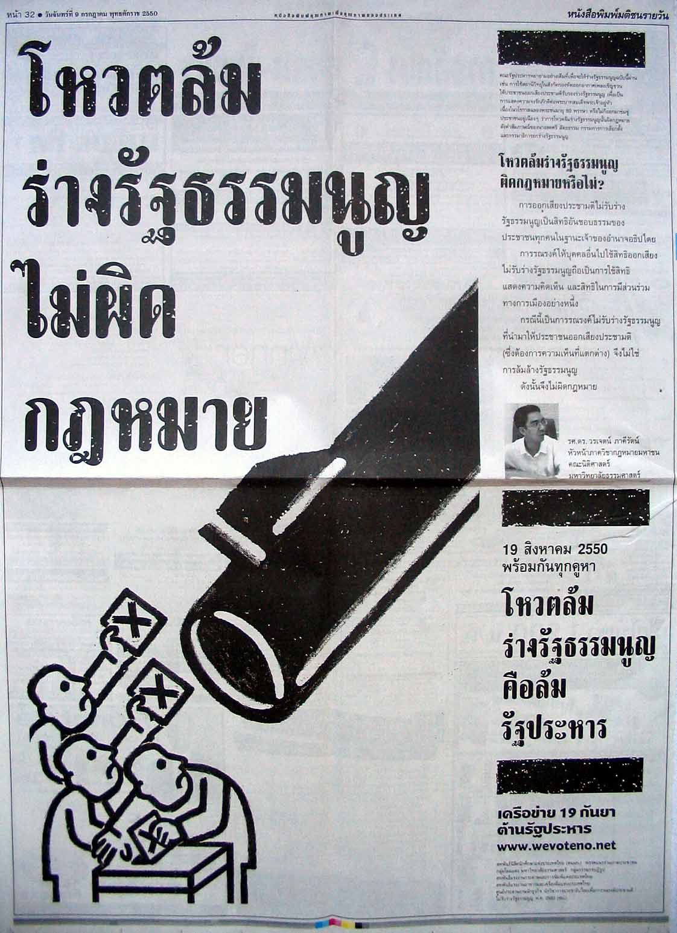

Picture 1: A full-page anti-draft constitution advertisement of the September 19 Network featuring Worachet Phakhirat of Thammasat University’s faculty of law, and the text “Voting to overthrow the draft constitution is not against the law” (Matichon, July 9, 2007)

I attended one such meeting in Bang Khla district, about half an hour by mini bus (song thaew) away from the provincial center. The committee’s part was listed in the meeting agenda under point 5 – right after an item about making reservations for a special version of the Jatukham Ramathep amulet. The heading was “Instructors will inform about and publicize the draft constitution.” With the agenda, participants received a manual on the referendum for the people, two information leaflets on the referendum produced by the Election Commission of Thailand (ECT), one CDA information leaflet, and later two more ECT leaflets (see picture 2). Needless to say, no anti-constitution material was distributed. Three or four members of the provincial CDA were there. The speaker was a grey-haired former village headman. When it was his turn, he talked for merely about five minutes in a rambling way, without any discernible structure in his presentation. Instead, he repeatedly waved the booklet with the draft constitution in the air. He did not even mention the strong points of the constitution according to the CDA leaflet. If this was about “selling” the constitution to an audience as important as the kamnan (sub-district headmen) and village headmen, then it was very poorly done indeed. At the end, the nai amphoe (chief district officer) looked at him with a slightly puzzled expression and asked “mi khae ni rue?” (“Is that all?”). Of the 300 people listed in the CDA’s action plan, about 220 were actually present.
After the CDA people had left, the nai amphoe addressed the audience on the issue of the constitution. He started by saying that there were only a few more days left until the referendum (this meeting took place on August 2, 2007). As they knew, the country was in bad shape; some factories had closed down. The baht was very strong, which was bad for exports, for example of shoes. In Bang Khla many people raised prawns for export. Other countries considered Thailand as not being a democracy and were thus hesitant about doing business here. Therefore, Thais had to stop their quarreling. One way of doing this was holding an election. If the draft constitution was not accepted, then the CNS (Council for National Security, the official name of the coup group) would select an earlier constitution. The holding of a referendum was stipulated in the interim constitution. For this reason, they should go and cast their vote, according to their respective opinions.
Some village headmen, the nai amphoe continued, had told him that they did not want to vote in the referendum. He asked them to reconsider their decisions and also urge their fellow villagers to cast their votes. There should be an election as soon as possible in order to return to democracy. A turnout of 50 percent would show the world that Thailand was on its way back to democracy. On August 19, a great number of votes should be cast in order to show the world that Thailand was a democracy. Repeatedly, the nai amphoe emphasized that he was only urging them to vote, while it was up to the individual whether he or she would vote for or against the constitution. This approach reflected the government’s official stance.
The nai amphoe expressly asked the kamnan and village headmen to bring villagers to the polling stations. This was not against the law, he pointed out. His statement reflected what had been said by national election commissioners, that—unlike in general elections—providing transportation for voters in the referendum was legal. At the end of his talk, the chief district officer called on those who wanted to vote in the referendum to raise their hands. All hands went up. He followed this up with the question, “And who would vote for the constitution?” Again, all hands seemed to go up. When he asked, “Who would vote against the constitution?” two people raised their hands. The nai amphoe himself did not seem to take this exercise too seriously.

Seven days after the event at the Bang Khla district office, I attended a similar promotional activity conducted in the context of the monthly meeting of the association (chomrom) of palat TAO of Chachoengsao, held at the province’s non-formal education center. The provincial CDA had asked for about 20 minutes to explain important aspects of the constitution. This was to be done by Somnuek Thaksina, the chairperson of the provincial chamber of commerce, and previously the chairperson of the provincial election commission. He had already played a major part during the public hearings on the draft constitution. Shortly before the meeting started, he arrived in his black Mercedes-Benz sports car and then waited to address the about 60 participants of the meeting.
The chomrom was not in a hurry to let Somnuek talk about the constitution. First, they had some association business matters to discuss. Then it was the turn of a company promoting the sale of cassettes with the Naresuan movie. They wanted the TAOs to buy it using their local-government budgets. This was followed by the information that Chachoengsao now had only 109 TAOs, after two of them had been upgraded to tambon municipalities. Some more business matters were followed by the representatives of the provincial public health office giving a talk about a health fund for local government authorities.
Finally, it was Khun Somnuek’s turn. He said that his committee wanted to write history and achieve a 70 percent voter turnout. This, he added, was directed against academics who had predicted a turnout of only 40-50 percent (the actual average turnout in Chachoengsao was 57.1 percent). In elections, the turnout could be as high as 75 percent, with payments made for transportation, etc. By contrast, the CDA had to rely on public relations. Somnuek then asked the palat TAO to urge people to cast their votes—like the nai amphoe in Bang Khla, he only asked them to promote a high turnout, not to urge people to vote in favor of the constitution. The very general talk lasted for only about five to six minutes. There was nothing about the content of the constitution. However, the CDA’s leaflets outlining what the drafters thought were the highlights of their product were distributed.

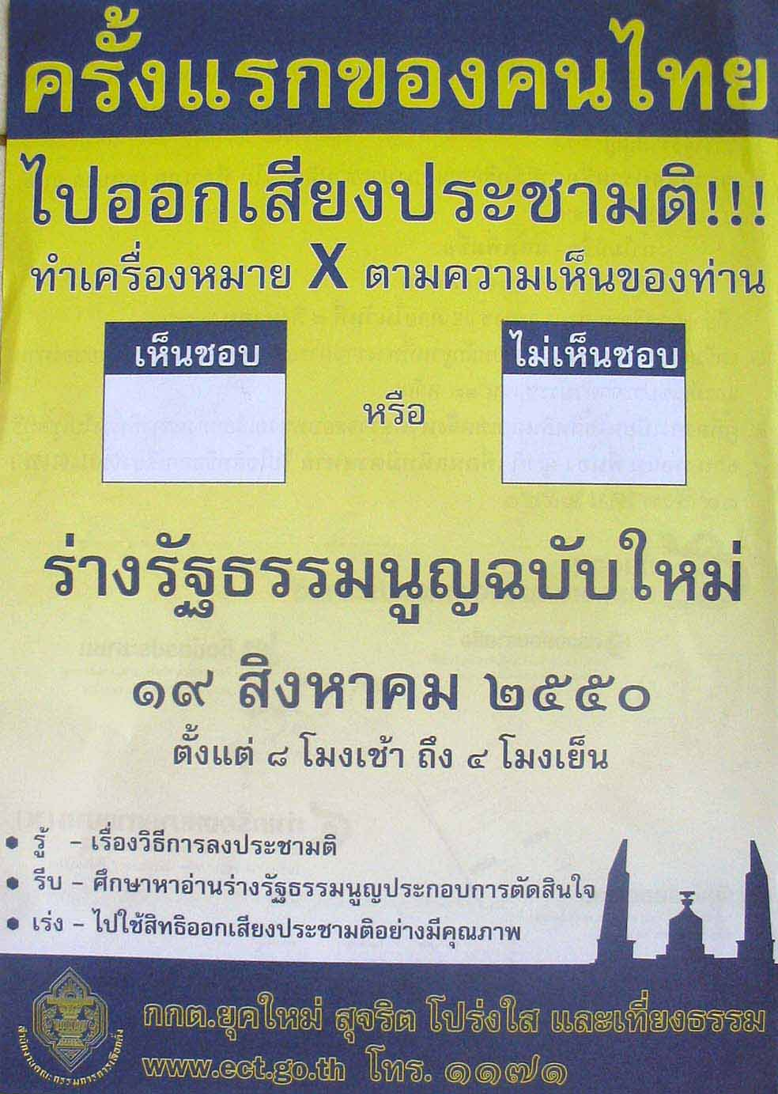

Picture 2: ECT leaflet promoting the referendum. Note that the background color is yellow.

One day later, in the afternoon of August 10, 2007, Khun Somnuek was in action for about ten minutes again at a student assembly at Chachoengsao’s Rajaphat University. It was an event in celebration of the Queen’s birthday. Both the CDA and the ECT leaflets were distributed. At this stop, Somnuek pointed out that the 1997 constitution had been considered Thailand’s best constitution, with the greatest degree of public participation in its production. However, after ten years of use, some problems were evident. For this reason, there had to be political reform. The present draft constitution was certainly better than the 1997 version. Following the general line, Khun Somnuek urged listeners to use their right to vote. He tried to improve the chances of compliance with this request by adding that the provincial governor had promised the Ministry of the Interior (MoI) that Chachoengsao would achieve a turnout of at least 70 percent—without explaining why the people of Chachoengsao should be concerned with what the highest-level bureaucrat in the province had promised the superiors in his ministry. Thus, the referendum on August 19 was a “national agenda” (wara haeng chat)—without explaining why the students should care about what some coup leaders and their auxiliary forces in Bangkok, claiming to act in the interest of the national good, had come up with. Whether they voted in favor or against the constitution – “mai pen rai” (never mind). But they should write democratic history for Chachoengsao as “children of Luang Pho Sothorn” (the revered Buddha statue of Chachoengsao)—again, without explaining how the Buddhist religion in general and the locally revered Luang Pho Sothorn statue in particular were related to the coup plotters’ and constitution drafters’ political intentions.
One might wonder about the kind of political culture that suggests that such statements will make the addressees—young, but supposedly self-assured mature citizens—inclined to follow one’s action-related requests. The provincial governor’s promise to his superiors in the MoI should have binding effects only on himself, and perhaps his fellow bureaucrats, but certainly not the people of the province. Yet, these governors are often called “pho mueang” (father of the province). In this context, the population of any province is seen as children in the conservative-hierarchical and bureaucratic order of things. Much as ordinary children, people in a province cannot chose their administrative fathers, because governors are appointed by the MoI. Governors are in no way accountable to their “children,” but are in a position to ask them to behave in specific ways.
As far as the “national agenda” is concerned, people in Chachoengsao should rather have been inclined towards resistance than compliance. After all, the coup had robbed them of their parliamentary representatives, chosen repeatedly in three successive elections, and of the resulting government. The reference to a “national agenda” is based on the idea that there is an abstract national good above ordinary political differences, and that actions based on such differences must cease as soon as those in power—in this case the supposedly disinterested military and bureaucratic guardians of the nation as a whole—can claim that this good is at stake. This element of an authoritarian political culture fits into the official ideological frame of reference concerning the Thai bureaucracy’s holy trinity of “chart, satsana, phramahakasat” (Nation, Religion, King).
There certainly is an element of Buddhism in Khun Somnuek’s reference of “children of Luang Pho Sothorn.” However, I do not think that this should be seen in the context of the satsana in the trinity. Rather, Somnuek tried to make use of a piece of more localized religious capital by suggesting that loyalty to Luang Pho Sothorn would necessitate that the students should go to vote in the referendum, and forget bad political feelings they might have had about the military coup. Moreover, listeners were again put into the position of children. This time, however, reference was not to hierarchical state power, but to a kind religious deity that had taken good fatherly care of his provincial children, for which reason his feelings should not be hurt. In any case, voting in the referendum, as political activity, probably should not have had anything to do with the voters’ religious belief in the benevolent powers of Luang Pho Sothorn. One can assume that Khun Somnuek did not really spend much time considering the three reasons described and briefly analyzed here. Rather, he was eager to find some supporting reasons for his request that students use their right to vote in the referendum. In his search, Somnuek grabbed familiar and ready-made pieces from his repertoire of political themes—which could be expected to be valid with his addressees too due to an at least partially shared political culture—irrespective of the actual motivational power of those themes.
Almost all of the provincial CDA’s activities to promote the draft constitution were of the kind that took place at the Bang Khla district office, the association of palat TAO, and the Rajaphat University. One of the perhaps two exceptions of presentations specifically organized to present the content of the draft targeted 100 representatives of Chachoengsao municipality’s 18 “communities” (chumchon; the actual number of participants was 60; the meeting was scheduled to run from 1000 to 1100 hours). Communities are semi-formal sub-divisions of a municipality, with elected committees and chairpersons, used by the municipal administration for implementing its policies and in support of citizen participation in problem solving. They might also serve as political support structures in the struggle for power among a city’s informal political cliques.

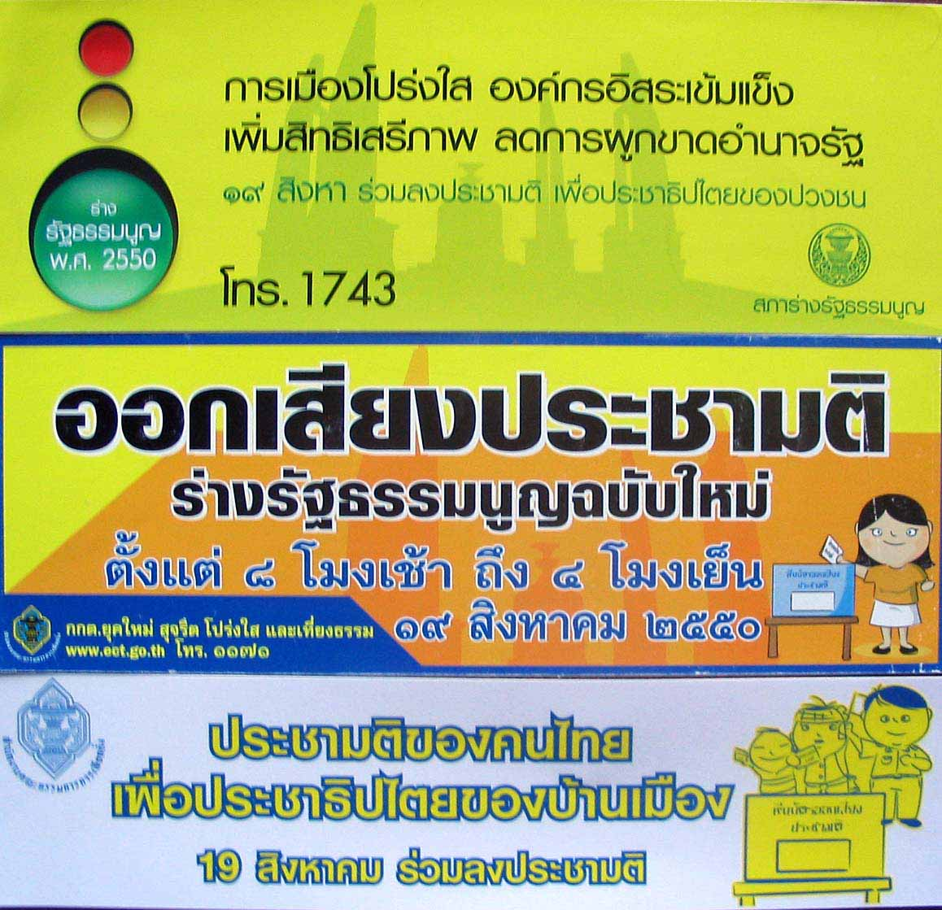

Picture 3: Three stickers advertising the draft constitution and the referendum, respectively.

As for Chachoengsao, this municipality has long been so strongly dominated by the Chaisaeng family that hardly any other candidates dared run in the local elections against this clique. One of Anand Chaisaeng’s sons, the luxury-inclined Konlayudh, has been serving as major for many years, while one brother (Chaturon) was a deputy TRT chairman as well as member of the government in various positions. One more brother (Wuthiphong) and a sister (Thitima) were constituency MPs for TRT, while family patriarch Anand held the position of advisor to Prime Minister Thaksin Shinawatra. Since the municipality was firm TRT (or rather Chaisaeng) territory, the provincial CDA people thus had taken on the up-hill task of selling the constitution to members of a political network that was firmly for the rejection of the draft constitution, as had been decided upon by the TRT, which, after the coup and Thaksin’s self-imposed exile, chose Chaturon Chaisaeng as its interim leader.
The event began with one of the vice-governors—who already had taken active part in the hearings on the draft constitution in his capacity as an advisor to the provincial CDA committee—talking about aspects of the constitution. He tried to deflect criticism on constitutional details by saying that nothing was ever perfect. Moreover, the referendum was not about voting in favor of the draft but rather about using the right to vote. Following the official line, the vice-governor emphasized the importance of a good turnout. Whether the constitution was accepted or rejected, there would be an election, only that in the latter case, it would be held after one of the earlier constitutions had been adopted by the CNS.
After about ten minutes, he left and Khun Manat, the secretary-general of the Chachoengsao Chamber of Commerce, who already had managed most of the hearings on the draft constitution, took over with a number of CDA-produced video clips, each lasting about six minutes. Manat’s question whether attendees had already read the constitution generated little response. He then showed the video clip on the constitution-drafting process. In this clip, it was said that this constitution-drafting process involved the most comprehensive participation of the people in Thai history, starting with the selection of the 2,000 members of the National Assembly. Moreover, the CDA had listened to a great number of organizations. After the first draft had been produced, even more public hearings were conducted. Obviously, these statements were a reflection of a piece of political culture, specifically that the 1997 constitution had been labeled the “people’s constitution.” One of the elements of this label concerned a supposedly far-reaching involvement of the people in the creation of this landmark legal document by the 1997-CDA. Therefore, the 2007-CDA must have felt the need to outdo their predecessors by claiming that their approach had been even better, and thereby undercut the possible negative motivational power that label might have had in the referendum. After all, one point of possible attack against the CDA and its product was that the drafters had been appointed by coup plotters and thus had to fulfill the military’s constitutional wishes. The CDA had to avoid having their document called a “coup constitution,” a label that would have compared poorly to the noble “people’s constitution.”
This clip ended with Prasong Sunsiri, the chairperson of the Constitution Drafting Committee, praising the four huajai samkhan (key points) of the constitution draft. These four points had been officially determined by the CDA in April 2007 after it had produced its first draft. In an English-language press release, these four points were listed as follows.

- Protection, promotion, and expansion of the rights and freedoms of the people;
- Reduction of concentration of power and elimination of its abuses;
- Making politics transparent, moral and ethical; and
- Strengthening and increasing the effectiveness of the scrutiny process by making the scrutiny bodies freer, stronger, and more efficient.

The next video clip advertised the mandatory policies laid down in the constitution, such as 12 years of free education—there would be no costs involved, while quality would be assured. This was quite a daring claim, one might say, given that ordinary Thai state schools have long been known for their lack of quality, and that all attempts at education reform have hardly led to any improvements. Surely, this constitutional promise will not materialize any time soon, as far as the element of “quality” is concerned. Moreover, only a certain basic quality might come free, while an economically and educationally competitive education quality will be reserved for the privileged, such as in well-known schools, or in two-class secondary schools, where the ordinary level is provided in Thai and largely free, while a higher-level English-language program is offered at a price for the wealthy.
As for health policy, there would be free care and support for sustainable health care, including participation by local governments. This policy obviously tried to trump the 30-baht health care policy introduced by the first Thaksin Shinawatra government. In fact, one of the first actions of the minister of health in the coup-appointed Surayud government was to make health care free. Furthermore, the video clip announced that there would be social welfare for the elderly, and better rights for the disabled. In sum, the speaker on the clip said the constitution intended to bring state welfare services to all citizens. Khun Manat summarized all this as “quality of life.”
This clip looked as if a political party was on the election campaign trail, trying to bag as many votes as possible with fancy policy promises. It is probably not so easy to differentiate “good” welfare state policies from Thaksin’s much-criticized “populism.” Why should free health care be good welfare policy, when the 30-baht program is evil populism? In any case, this clip should have been appropriate for the audience of this meeting, because most representatives from the municipality’s communities seemed to be of modest economic status. However, why should they fall for the copy (the CDA-constitution) when they already had experienced the original (TRT-Thaksin)?
The final clip was about community rights in the care for a locality’s natural resources. I am not sure whether this issue was very attractive to the participants, since they lived in an urbanized area. From time to time, Khun Manat would stop the video clip to explain something further. For example, he mentioned that they could directly petition the Constitutional Court if they thought that their constitutional rights had been violated. In closing the one-hour meeting, he thanked the municipality for having organized this meeting—without any of its political leaders having turned up.

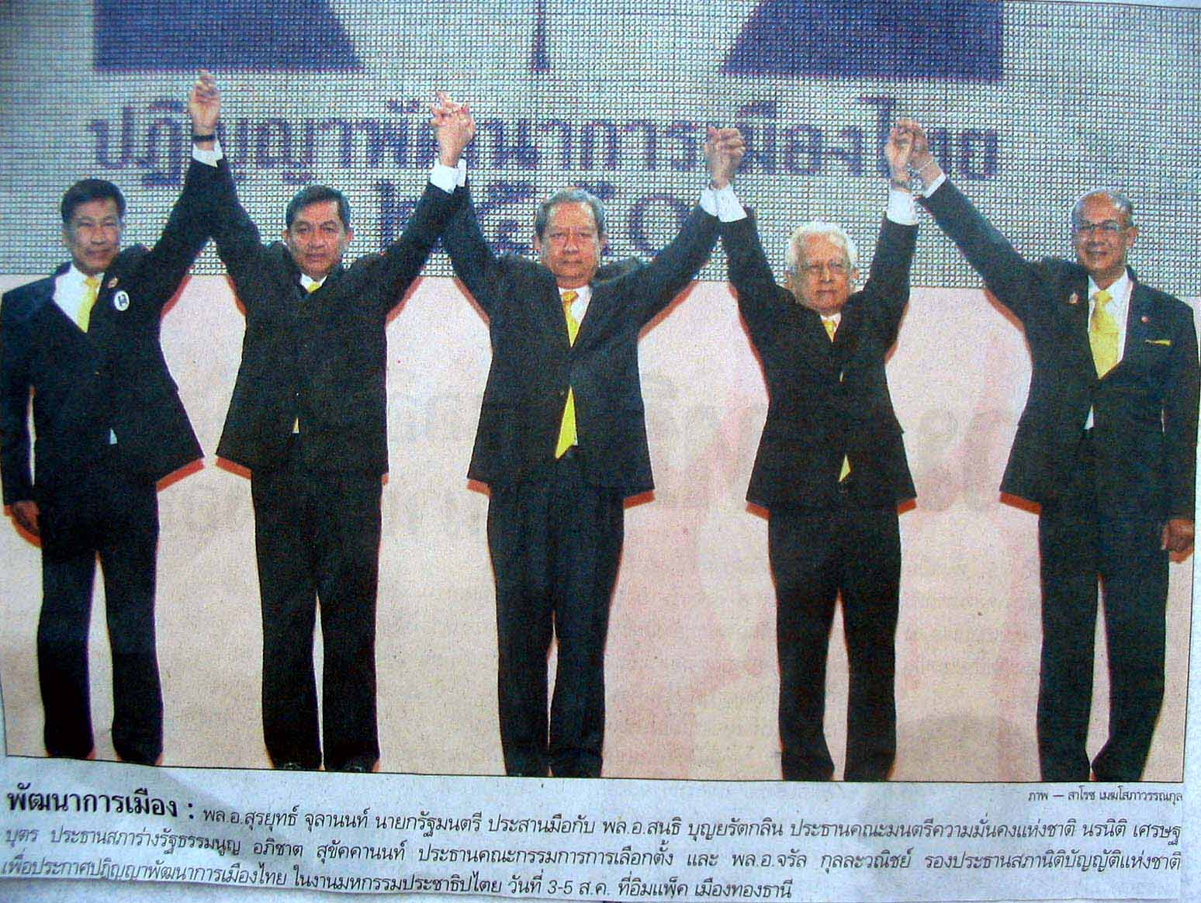

Picture 4: ECT chairman, Apichart Sukhakkhanon (on the left), lifting the hand of coup-leader Sondhi Bunyaratglin (Post Today, August 4, 2007, front page). In the middle is Prime Minister Surayud Chulanond. On his right are Noranit Sethabutr, chairperson of the CDA, and deputy NLA speaker Charan Kullawanit. The picture was taken at the coup complex’s major pro-constitution rally at the Impact Arena, Muang Thong Thani. Note that all four wear yellow ties to indicate that they acted within the dominant bureaucratic-royalist political frame of reference.

On the home stretch of the referendum campaign, the provincial CDA also hired state schools to drum up support for the draft constitution. Campaign walks (doenthang ronnarong) were held between August 14 and 17 in all districts, with two to four schools participating in each of the altogether 35 events. On August 15, 2007, I traveled to Bang Nam Prioew market, which is located about 30 minutes by minibus from the provincial center. When I arrived, the students, many wearing yellow shirts, had already assembled in front of the flagpole of Bang Nam Prioew Withaya, a secondary school. From there, they walked along part of the main road that runs through the market to the district office, where they took a break, then walked back to the end of the main road, made a U-turn and walked back to their starting point in the school’s compound. The students were led by a marching band and students waving huge flags. They carried the CDA’s posters urging people to give the green light for the draft constitution in the referendum. Students accompanying the column distributed the CDA’s green-light leaflets (no ECT leaflets were distributed) to the shopkeepers and their customers. At the end of the column was a pick-up truck converted to a campaign vehicle. The recorded announcement played from this truck did not merely urge people to vote in the referendum. Rather, it specifically praised the draft constitution, because it would make politics transparent, strengthen independent organizations, increase the rights of the people, and reduce the monopoly of state power. Thus, the message mirrored what could be seen on the leaflets, the posters carried by the students, and the CDA-produced stickers.
In short, this was not a rally that merely aimed at achieving a good turnout in the referendum. It was a campaign event aimed at asking people to vote in favor of the draft constitution. The non-state CDA and its provincial committee used a state mechanism, namely schools and their students, including some officials from the district administration, as tools in order to realize its political self-interest. The CDA, unlike the counter-constitutional forces, could use these state mechanisms because schools and district officials, as much as itself, were part of the military-directed power structure, whose goal was to see the constitution through.
The climax of this part of the provincial CDA’s pro-constitution referendum campaign took place two days before the vote, on August 17, 2007, opposite the provincial hall at an open multi-purpose hall called sala thai. Seven state schools and one private (St. Louis) school took part in this opening event. Afterwards, they paraded on different routes through parts of the city, promoting a “yes” vote by carrying the respective posters, and distributing the CDA’s leaflets, posters, and stickers.
Picture 5 on the next page shows the setting of the stage. Two big cut-outs at the left and right side repeated the main thrust of the campaign, specifically “give the green light to the draft constitution.” Similarly, the large banner covering the backside of the stage repeated the four key selling points of the draft constitution: transparent politics, strong independent organizations, more rights and liberties and reduction of the monopoly on state power. All this was placed in the context of the official bureaucratic-royalist “politics of the color yellow,” meaning that a connection was suggested between this constitution (the front and back covers of the copies sent to the people for pre-referendum study were also yellow), a “yes” vote in the referendum, and the people’s loyalty to the King. The core of the implied message was that voters loyal to the King could not possibly reject the draft constitution. In other words, the CDA and its provincial branches made use of the official bureaucratic-royalist sector of Thai political culture in order to convince voters that they should accept the draft charter. One needs to recall in this context that the draft constitution was designed as a major anti-Thaksin instrument, and that one of the justifications the coup-plotters gave for their act was that then-Prime Minister Thaksin Shinawatra had been disloyal to the King.

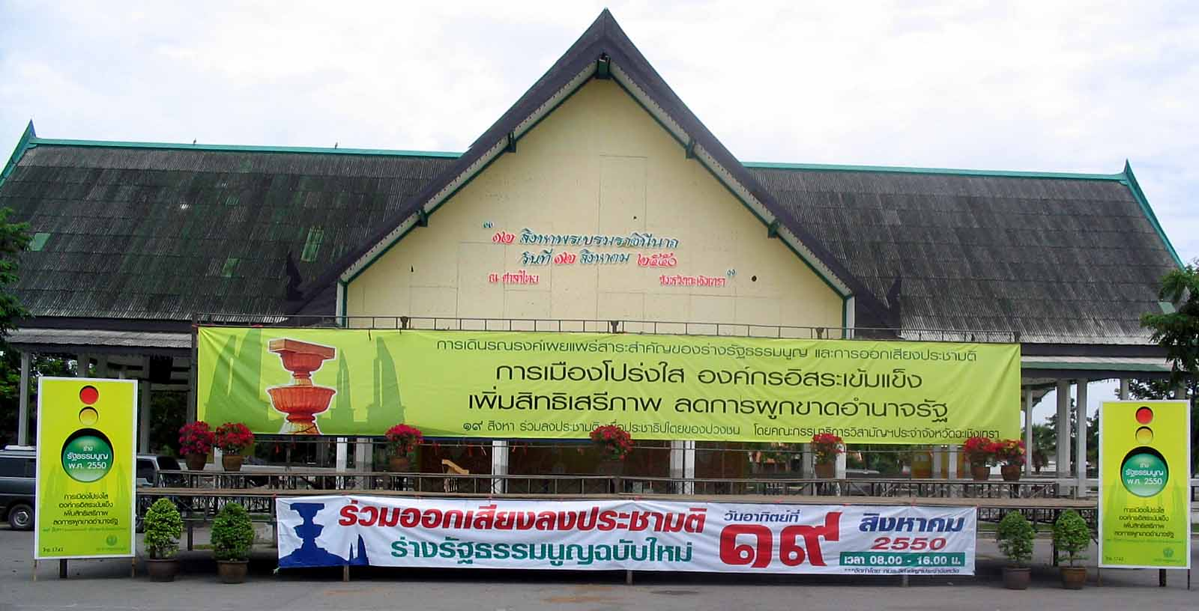

Picture 5: The setting of the stage at sala thai on August 17, 2007, on the occasion of the provincial CDA’s concluding leg of school-supported referendum campaign
rallies.

The event was to start at 0900 hours. The provincial CDA, provincial civil servants (both of these groups were of course clad in yellow clothes), soldiers and policemen took their positions on the stage waiting for the provincial governor, who was to open the event. Khun Somnuek acted as the moderator to fill in the time. After a while, the provincial governor, dressed in a yellow jacket, arrived in his S-class Mercedes Benz. Following the usual Thai format for such official events, a representative of the host institution, in this case Khun Okart of the provincial CDA, addressed the provincial governor, formally explaining what this function was about in what is called “report” (raingan). Afterwards, the governor delivered his opening speech. In order to communicate an integrated impression of how the governor approached his task, I reproduce his address in full as follows.

Address by the chairperson

Holding a ‘campaign walk to promote and publicize important contents of the draft constitution and holding the referendum’ Friday, 17 August 2007 at 0900 hours at sala thai in front of sala klang province of Chachoengsao.
________________________

Chairperson and members of the extraordinary committee for public hearings and participation, province of Chachoengsao, civil servants, democracy development volunteers, students, businesspeople, fellow citizens from all mass organizations, and all honorable participants.
It is a great pleasure and honor for me to be the chairperson today of holding a ‘campaign walk to promote and publicize important contents of the draft constitution and holding the referendum’.
From the report, we see that the referendum on the draft constitution of 2007 has great importance for the development of the Thai democratic system of politics and government that has the king as head of state, because the constitution is the highest law for governing the country, concerning the legislative, executive, and judicial powers. The draft constitution of 2007 stipulates essential features such as to more clearly promote and protect the rights and liberties of the people, and to support that people concretely and effectively play roles and participate in government and in checking the use of power. It provides for political-institutional mechanisms so that all sectors, especially the legislative and the executive, will have balance and efficiency according to the parliamentary democratic system of government that has the king as head of state. It promotes judicial institutions and other independent organizations to be able to perform their duties honestly and fairly, and being above other things, and it emphasizes the value and the importance of ethics and the method of good governance, which are the foundations for developing the nation. The Constitution Drafting Assembly has already publicized the draft constitution so that the fellow citizens will know it and use it as data in their considerations. Therefore, since the people have already considered the content of the draft constitution, I would thus like to cordially invite my fellow citizens as follows.
1. Invite all people who have the right to vote to come out and use their rights to vote for ‘accept’ or ‘reject’ the draft constitution in the referendum that will take place on Sunday, 19 August 2007 from 0800 hours – 1600 hours.
2. Ask the people to use the occasion of this referendum on the draft constitution to demonstrate that they dearly love and repay the kindness of the country where they were born as well as to show that the people in this nation share the same opinion.
3. Ask the people not to mistakenly believe those who have bad intentions and try to use the power of money or other means to prevent people from using their rights to vote in the referendum on the draft constitution.
4. Ask civil servants, state employees and officials to be strictly neutral in the referendum, and this time fulfill their important duties of the country to the fullest of their strength and capability. Refrain from doing anything that guides voters to vote ‘accept’ or ‘reject’ the draft constitution, and also be an example for the people by using your right to vote in the referendum.
I would like to thank the extraordinary committee of the province of Chachoengsao and all those who have been involved in organizing this activity. I call on the power and prestige of luang pho phutthasothorn and all sacred things of the world, the prestige of his Majesty the King, to wish my fellow citizens all the best. May everybody have happiness and prosperity, the four kinds of happiness, and be successful in every respect that you desire. Now the time has come already – I declare open the ‘campaign walk to promote and publicize important contents of the draft constitution and holding the referendum’. Thank you.

Not surprisingly, the governor reiterated some issues seen as selling points of the draft constitution. The second point of his “invitation” is perhaps somewhat ambivalent, because “the same opinion” (samanachan), in the given context at that time, came close to asking the people to close ranks against the remnants of the so-called “Thaksin regime” or the “old powers,” that is asking them to approve the constitution. Since the military coup officially had saved the nation from great danger, and since the draft constitution was supposedly designed to avert such danger in the future, the governor’s reference to “repay the kindness of the country where they were born” can also be seen as promoting a pro-constitution stance.
What was indeed surprising in this context was that the governor still asked civil servants to be “strictly neutral.” If he had followed his own advice, how could he have opened this event; how could he have supported the use of state schools, students, teachers, and other civil servants to clearly urge voters to pass the draft constitution? This was not at all impartial. One wonders how he would have reacted if the Chaisaengs, as representatives of TRT’s anti-constitution forces, had asked for permission to use the same venue and the same schools to promote their stance, and invited the governor to address their event as well.

Besides the activities described above, the provincial CDA committee had also prepared envelopes for the 34 community radio stations of Chachoengsao (hardly any of them seem to be licensed, though they seem to be well known and registered with the provincial public relations office). I was present when a representative of one such station turned up at the office of the provincial chamber of commerce and picked up his envelope, not without signing his name in a prepared list. The envelopes contained the CDA leaflets with the important points, which announcers were supposed to read to their audiences, and CDs with spots to be broadcast. For some time before the referendum, the announcers on the local MSS cable television station were dressed in yellow shirts with the date of the referendum printed on the chest. The same station broadcast several parts of an interview with Khun Okart on aspects of the draft constitution. Unfortunately, he was not very articulate so it was mostly the interviewer who talked and then asked Khun Okart whether what he had said was correct.
Finally, the provincial CDA had asked one of the local newspapers, Dao Paetriu, to print one page of its promotional leaflet, at the price of 3,000 baht. Eleven CDA-hired modified pick-up trucks had been roaming the streets of Chachoengsao advertising the referendum and the constitution. Furthermore, according to Khun Manat, there were slightly over 20 relatively small yellow billboards with the traffic-light motif, basically enlarged versions of the sticker seen in picture 3, placed at important intersections throughout the province. I had seen some of these billboards, so I inquired about the total number.

In sum, the provincial CDA had tried to use the available means in order to promote a “yes” vote. They largely worked on their own, using the very limited facilities of the office of the provincial chamber of commerce, with little guidance and support from the national-level CDA. The propaganda offensive anticipated by some commentators did not materialize, because the budget seems to have been far too limited.
Obviously, I cannot say anything on what state agencies did concerning the promotion of the constitution and counteracting anti-constitution activities at the district, tambon and village levels, simply because I was largely confined to the provincial capital. The Ministry of the Interior’s “democracy volunteers” might have performed some activities, or they might merely have played a more usual symbolic role without having any significant practical impact. Since the press had variously mentioned that the Internal Security Operations Command (ISOC) might play an important role in suppressing anti-constitution activities, I did look up the deputy representative of this organization in Chachoengsao. It apparently has only a handful of staff members, and resides in two rooms opposite those used by the provincial chamber of commerce. I presented the deputy with an article from Post Today saying that ISOC in the North aimed at reaching about 80 percent of all voters in their attempt to make them go to cast their votes in the referendum. He said they did not have anything like this in Chachoengsao. In fact, they had no activities on their own. Rather, they merely “coordinated” with other agencies.

I will now turn to the question of how much of a voice was given to the anti-constitution groups.

Rejecting the draft constitution

Given that, at the national-level, there were sustained attempts at closing the public space for anti-constitution campaigns, readers might expect that this section will be much shorter than the one that dealt with the pro-constitution campaign. Indeed, hardly any anti-constitution messages were visible in Chachoengsao. Groups such as the September 19 Network might have been able to place a small number of advertisements in national newspapers. However, they certainly did not reach down to the provinces to any significant extent, although their material might have been accessed by some in the up-country audience via the Internet. Being located in Chachoengsao, I also could access their message only through the newspapers, or the Internet, including the web site Prachatai. Thus, it can safely be assumed that such groups basically had no motivational impact on the up-country voters’ decisions to vote in favor or against the draft constitution. Some more exposure might have been achieved by the at least three televised debates, in which both the pro and the contra camps were given time to present their respective opinions. However, it is doubtful how many people stuck to the screen to hear the more-than-hour-long presentations of abstract constitutional issues.
On August 1, 2007, from 1300 to 1600 hours, lecturers at the Rajaphat University organized a discussion on the draft constitution in the university’s big meeting hall. A small number of banners in town had advertised this event some days in advance. The organizers had invited speakers from both sides of the spectrum, such as Chaturon Chaisaeng and Abhisit Vejjajiva. Trakul Meechai from the Faculty of Political Science of Chulalongkorn University was the moderator, while one of his colleagues, Prapas Pintobtaeng, would act as the second anti-constitution voice. As for Chaturon, he did not turn up. According to one ajarn, Chaturon had phoned him the day before at 1700 hours to cancel the appearance that he had firmly promised. Chaturon had told him that he would be abroad (but only a few days later, he participated in the national-level TV debate). His replacement was TRT’s eloquent Dr. Phiraphan Phasusuk.
I thought that Chaturon should have nominated his brother, former TRT MP Wuthipong. First, this was a local affair in the family’s stronghold. Second, Wuthipong had been Chachoengsao’s representative in the CDA that drafted the 1997 Constitution. Thus, he should have had something to say on the 2007 version, compared to the document he had a part in drafting. When I suggested this to a contact, she said “He is not a speaker,” which is quite right. Unlike Chaturon, who is a polished speaker, Wuthipong has problems delivering appealing and convincing spoken public statements. Abhisit also failed to appear. Demagogically-inclined Alongkorn Pollabutr stood in for him. The lecturer said that Abhisit had important activities at the national level and a long queue. Thus, it had been clear that Alongkorn would be the speaker for the Democrat party. He then spoke as if he was the spokesperson of the CDA.
In any case, although this event had been advertised, the audience consisted almost exclusively of the Rajaphat University’s own students. A lecturer remarked to me, “The students have no interest in the constitution. They were ordered by their lecturers to turn up at the event.” As far as I could see, there were no more than perhaps 20 members of the general public in the audience, plus about 300 students. When they entered the hall, there were tables on the left side of the entrance from where they received the CDA’s promotional leaflets and a small pro-constitution brochure produced by the Faculty of Political Science of Chulalongkorn University. I wondered whether there were any leaflets from the opposition TRT camp, especially since pictures of those TRT brochures had been printed in the newspapers. I thought that the TRT’s representative had probably brought a stack of them with him for distribution. Therefore, I walked along the tables at the entrance and then turned to the left where some more tables were placed with some name signs, amongst them that of Chaturon. Still, there were only these signs, without any promotional material. I specifically looked out for a display of the TRT brochures, but saw none. However, on my second attempt, I looked more carefully and found a small pile of them in front of two lecturers from the Rajaphat University’s faculty of public administration. They had put some other documents on top of that pile, making the brochures barely visible. For this reason, people who did not know that there was such a brochure and that it had a red cover, had very little chance indeed of discovering it. I cannot recall seeing any students with the red TRT brochures, although most had received the yellow CDA leaflets.
As far as I know, this was the only “debate” amongst proponents and opponents of the draft constitution in Chachoengsao. It was not organized by the CDA or TRT, but by lecturers of Rajaphat University, who thought that both sides should be presented to the province’s public. Yet, with an audience consisting mainly of uninterested students, the reach of this event in terms of shaping the motivation of the voters to cast their ballots either for or against the draft was certainly very limited.

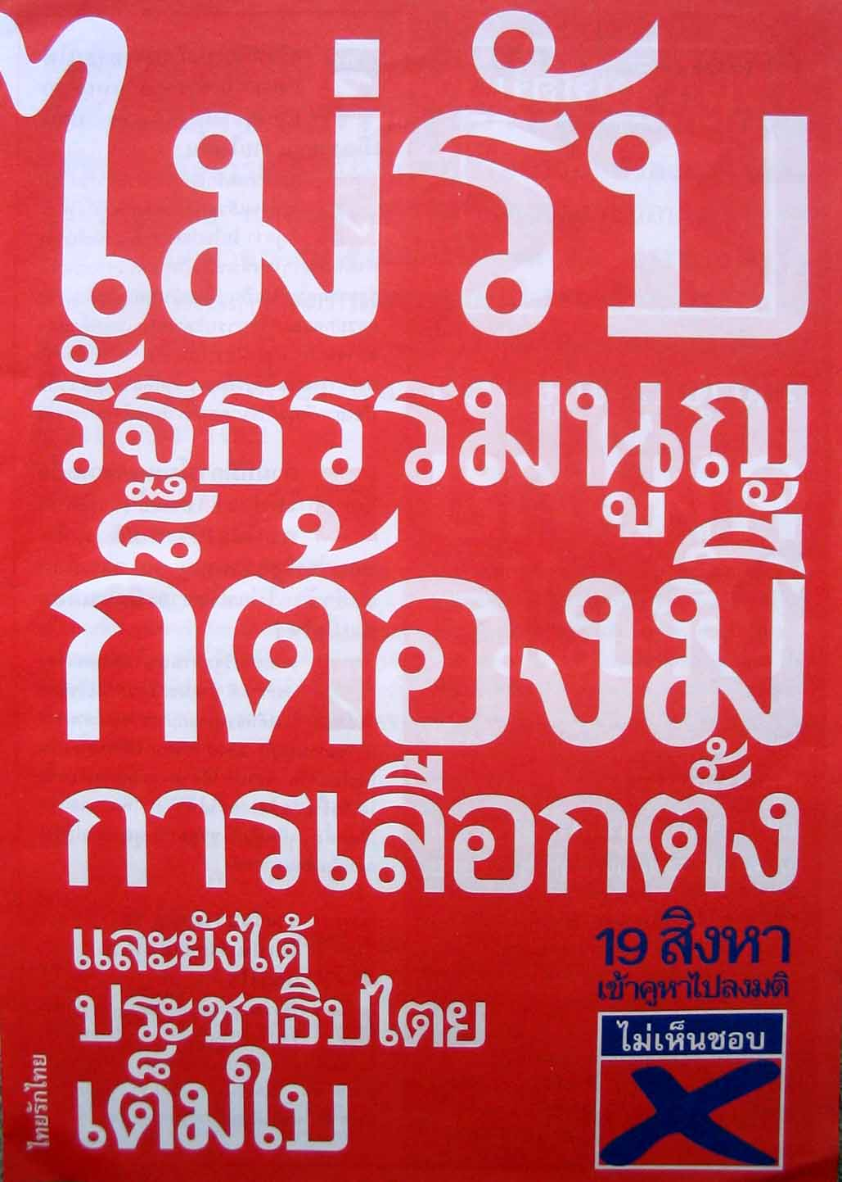

Picture 6: Front cover of a four-page TRT leaflet distributed at the Chaisaeng’s anti-constitution rally around bobua fresh market on August 18, 2007

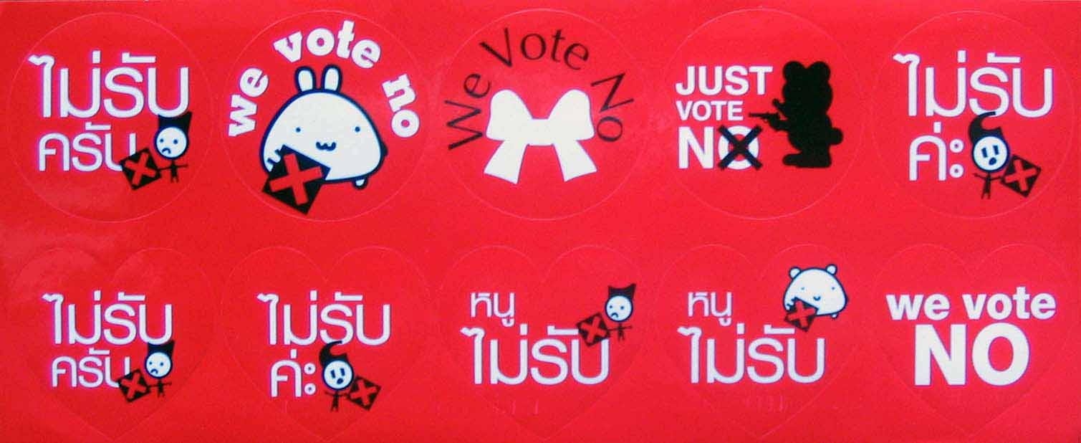

Picture 7: Small round stickers that were attached to the tops of the mostly female market vendors at bobua market by Thitima Chaisaeng, former TRT MP

On August 14, 2007, having seen no campaign action whatsoever from the TRT camp up to that date, and only five days left to the referendum on August 19, I finally decided to go to the house of the Chaisaengs, which also houses TRT’s, or shall I say Wuthipong’s and Thitima’s, MP office. The two secretaries and a man recognized me from previous visits and observations of their campaign rallies. TRT’s anti-constitution leaflets (picture 6), stickers (picture 7), and a CD with Chaturon’s speech given at the main TV debate had just arrived. There was also a set of a six-page anonymous anti-constitution document that had come by ordinary mail; one of the ladies kindly photocopied it for me. They told me that they would do a campaign walk on Saturday, August 18, starting at 0600 hours, from the Chaisaeng’s house to the bobua fresh market. As far as I know, this was to be the first and only formal open activity in opposition to the draft constitution in Chachoengsao province.
After I had talked with the ladies in the office, I had a long chat about a number of topics with Wuthipong Chaisaeng in the living room of his house. On my question why the Chaisaeng family obviously had not put together any systematic anti-constitution campaign, except for Chaturon’s appearances at a number of events at the national level, he said that he had also thought of doing some campaigning using a car with a loudspeaker system. However, these were not democratic times. He did not want to provoke the military and police by doing anything openly. Moreover, he had to think about what might happen to those who would participate in those activities. There might be some sort of check bin[ll] (this expression is normally used in better restaurants if a person wants to pay the bill; it is used here in the sense of negative consequences of one’s actions). The kamnan and village headmen did not dare do anything, because they knew they were being watched. Therefore, he had only talked to some groups of local leaders, especially on the occasion of his birthday last week, when they came to congratulate him.
On August 6, 2007, Wuthipong had talked about sports activities in his capacity as chairperson of the Sports Association of Chachoengsao at a regular meeting for school administrators at the office of education district 1 (Chachoengsao has two education districts). Representatives of the provincial CDA then presented what they thought were the good points of the draft constitution. Afterwards, Wuthipong spent some time listing what he thought were negative points. According to him, he then left it to the participants to vote according to their beliefs, and he did not distribute any anti-constitution material.
On the day of the Chaisaeng’s anti-constitution campaign walk, I arrived at their house at 0600 hours. There were only cars in the yard and the household dog in front; no people in sight. I was afraid they had called off the event, and went to bobua market to check, and then returned to the house. By that time, people had started to arrive at the house. Most of them were dressed in red shirts, mostly with the no-vote design. At 0655 hours, about 60 people started their march from the soi to the market, some of them carrying cutouts and posters with messages such as “we vote NO” (in English), “19 August, join voting in the referendum,” and “even if the constitution is rejected, there will be an election”. This latter message was also carried by a pick-up truck that had been converted to a campaign vehicle. Rather than playing an anti-constitution jingle, the driver used the speech that Chaturon had delivered at the main constitutional debate some weeks earlier.
At 0830 hours, when they had reached Dat Darunee School at the town’s main intersection, after they had campaigned at the market, about 200 people were in the march. The socio-economic composition of participants was quite similar to what could be observed at the anti-coup rallies of the Democratic Alliance Against Dictatorship (DAAD) at Sanam Luang, namely mobilized lower-income people. There were no middle-class academics, civil servants, business people, or Rajaphat University students in the march. It had also not been announced in advance to the provincial public. If I had not gone to the Chaisaengs’ house on that day, I would never have known that this anti-constitution campaign activity would take place.
Thitima Chaisaeng attached no-vote stickers (picture 7) to the market traders’ tops and distributed TRT’s anti-constitution brochures (picture 6), as did some of her assistants. Within bobua market, Wuthipong held a small microphone connected to a loudspeaker carried by one of his helpers. This way, he talked about the draft constitution and its negative points. Wuthipong also occasionally stopped or sat down to talk to people. After some time, the supply of stickers and brochures was exhausted, while there were technical limits to the distribution of a video compact disk with Chaturon’s speech since it could not be expected that all shopkeepers had computers. In addition, watching a 20-minute speech requires much more effort than merely opening a brochure and scanning it. The title of the VCD suggested that a vote against the draft constitution was a way of demonstrating one’s rejection of the military coup: “Join the vote against the draft constitution of 2007 on 19 August 2007: disapprove of the draft constitution 07 – disapprove of the military coup.”
Most of the female market vendors did not object to getting the small sticker. Few showed much of a reaction, either positive or negative. Of course, they could easily remove the stickers after the Chaisaeng group had passed. This way, they could keep social harmony in the brief interaction and at the same time avoid showing a certain political stance afterwards. One lady, upon passing the group in the market, disapprovingly uttered “I want to see elections held soon!” Anand Chaisaeng, the family patriarch, paid a brief visit to the protest march, while the police loosely observed it.
On referendum day, I observed the vote counting in two polling stations made up of tents near to bobua market. In the course of the counting, it became increasingly clear that the voters had unambiguously approved the draft. A secondary school student who had participated in the Chaisaeng’s anti-constitution campaign event also observed the counting. After a while, he turned to me saying “Lung (uncle), our march yesterday does not seem to have had any much of an effect.” However, one might not really expect an effect from a single march done just one day before the vote, given the general political situation and the sustained pro-constitution public relations by state agencies.

Managing the referendum: the provincial election commission

Like the national-level Election Commission of Thailand (ECT), the provincial election commissions (PEC) are each composed of a board, selected for a certain period of time, and a permanent office. It is the latter that carries the burden of administering elections and the referendum. In Chachoengsao, the office had 15 staff members as shown in chart 1. Since the office was established after the original ECT Act came into effect in June 1998, its officials have gained a great deal of experience and competence concerning the management of national and local elections. Thus, they can approach any new vote largely as a routine affair although, of course, it still requires much work. Moreover, from having performed many elections already, the PEC offices also have well-established networks in the district administrations and amongst education officials. By comparison, at the time of the referendum, the election commissioners were still learning their jobs, having been appointed only a few weeks earlier, on July 3, 2007.
To facilitate its work on the referendum, the PEC had produced two main administrative documents containing information on the organization of the referendum process. One was the “Plans for managing the voting in the referendum, Chachoengsao province, Sothorn 4,” while the second was called “Data summary on the preparation of the voting in the referendum, Chachoengsao province, 2007.”

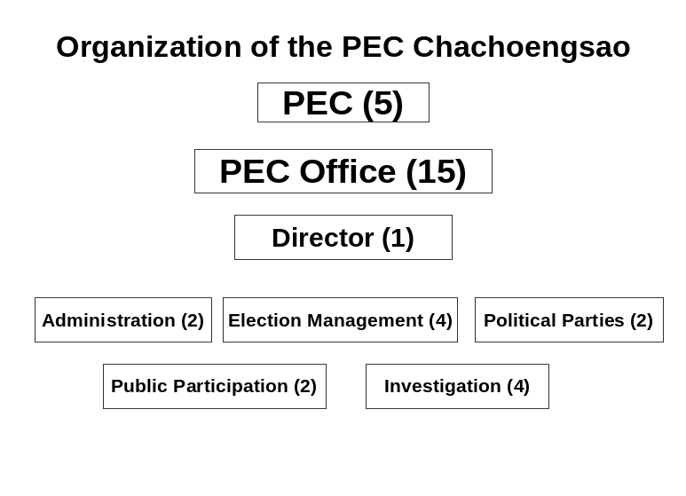

Chart 1: Organizational structure of the provincial election commission and its office in Chachoengsao province

The second photocopied booklet also contained the referendum calendar, or ปฏิทินการดำเนินงานการออกเสียงประชามติ จังหวัดฉะเชิงเทรา วันออกเสียงประชามติ 19 สิงหาคม 2550, pp. 7-8, as follows.

1) Establish the referendum command center, province of Chachoengsao: July 9-10, 2007 (responsible agency: Office of the Election Commission, province of Chachoengsao)

2) Appoint the referendum sub-committees in the districts/semi-district: July 9-13, 2007 (Office of the Election Commission, province of Chachoengsao)

3) Register the use of voting rights outside one’s province: July 10-19, 2007 (offices of the district/semi-district registrars and offices of the local government registrars)

4) Announce the referendum polling stations: July 29, 2007 (referendum sub-committees in the districts/semi-district)

5) Announce the lists of people who have the right to vote in the referendum: July 29, 2007 (referendum sub-committees in the districts/semi-district)

6) Offices of the district/semi-district registrars and offices of the local government registrars receive requests for adding or deleting names (from the voter rolls): July 29-August 8 (district/semi-district registrars and local government registrars)

7) Offices of the district/semi-district registrars inform the household heads about who has the right to vote in the referendum: July 30-August 30, 2007 (offices of the district/semi-district registrars and offices of the local government registrars; postal service)

8) Appoint polling station committees, counting officials, and security personnel: July 30-August 3, 2007 (referendum sub-committees in the districts/semi-district)

9) Offices of the district/semi-district registrars and offices of the local government registrars print revised voter rolls regarding added names: August 9-10, 2007 (district/semi-district registrars and offices of local government registrars)

10) Training of the polling station committees, counting officials, security personnel, and directors of the polling stations: August 11-18, 2007 (referendum sub-committees in the districts/semi-district)

11) Last day for announcing the change of polling stations: August 13, 2007 (referendum sub-committees in the districts/semi-district)

12) Report of the preparedness regarding the referendum: August 15, 2007 (referendum sub-committees in the districts/semi-district, and Office of the Provincial Election Commission)

13) The polling station committees receive their voting utensils (ballot papers, ballot boxes, forms, and other materials): August 18, 2007 (referendum sub-committees in the districts/semi-district)

14) Referendum day; prepare receiving the ballot boxes and calculating the votes: August 19, 2007 (Office of the Provincial Election Commission, referendum sub-committees in the districts/semi-district)

15) Report the result of vote counting in the referendum to the Election Commission of Thailand (Office of the Provincial Election Commission)

The photocopied management plans booklet mainly (pp. 16-64) collected the 11 separate plans regarding the management of various aspects of organizing the referendum as follows.

1. Work plan for managing the referendum, Chachoengsao province
2. Referendum campaign plan
3. Work plan for campaigning and publicizing the process of voting in the referendum
4. Plan for the recruitment, appointment, and training of polling station committees
5. Work plan for maintaining security, peace and order in the referendum
6. Plan for providing utensils for the voting in the referendum
7. Plan concerning the voting in the referendum for voters from outside the province
8. Communication plan
9. Plan for the administration of budget and finance
10. Plan for tallying the votes and reporting the result
11. Plan concerning objections to the voting in the referendum

The pages 65-72 listed the respective responsibilities of the office of the PEC and the referendum sub-committees in the districts and the semi-district.
Besides the usual means of public relations, such as leaflets, stickers, and promotional walks by school children, the PEC, on order from the ECT, also employed the innovative approach of “direct sales.” Students from a number of schools were recruited for five days to call thousands of voters at home to ask them whether they knew that a referendum would take place on August 19, and whether they intended to cast their votes. They did not ask how people would vote, nor did they suggest how they should mark their ballots. At the end of each call, callers had to fill in a row on a form, giving the name of the person called, their telephone number, whether the person who answered the phone was the household head, and whether or not the respondent intended to vote in the referendum.
The students were lined up along a long line of tables, located in the corridor next to the PEC office in the old part of the provincial hall, equipped with dozens of telephones and lists that seemed to have been copied from the local telephone directory. When I asked a supervising teacher, he told me that they had 50 students, each of whom was supposed to call 60 numbers during the day. They had divided this project into a morning and an afternoon shift. The morning was covered by girls, the afternoon by students from the technical college (at least on the first day that I saw them). Thus, altogether, about 15,000 of Chachoengsao’s 477,492 eligible voters should have been called, since this activity lasted from Tuesday to Saturday, the last five days before referendum day.

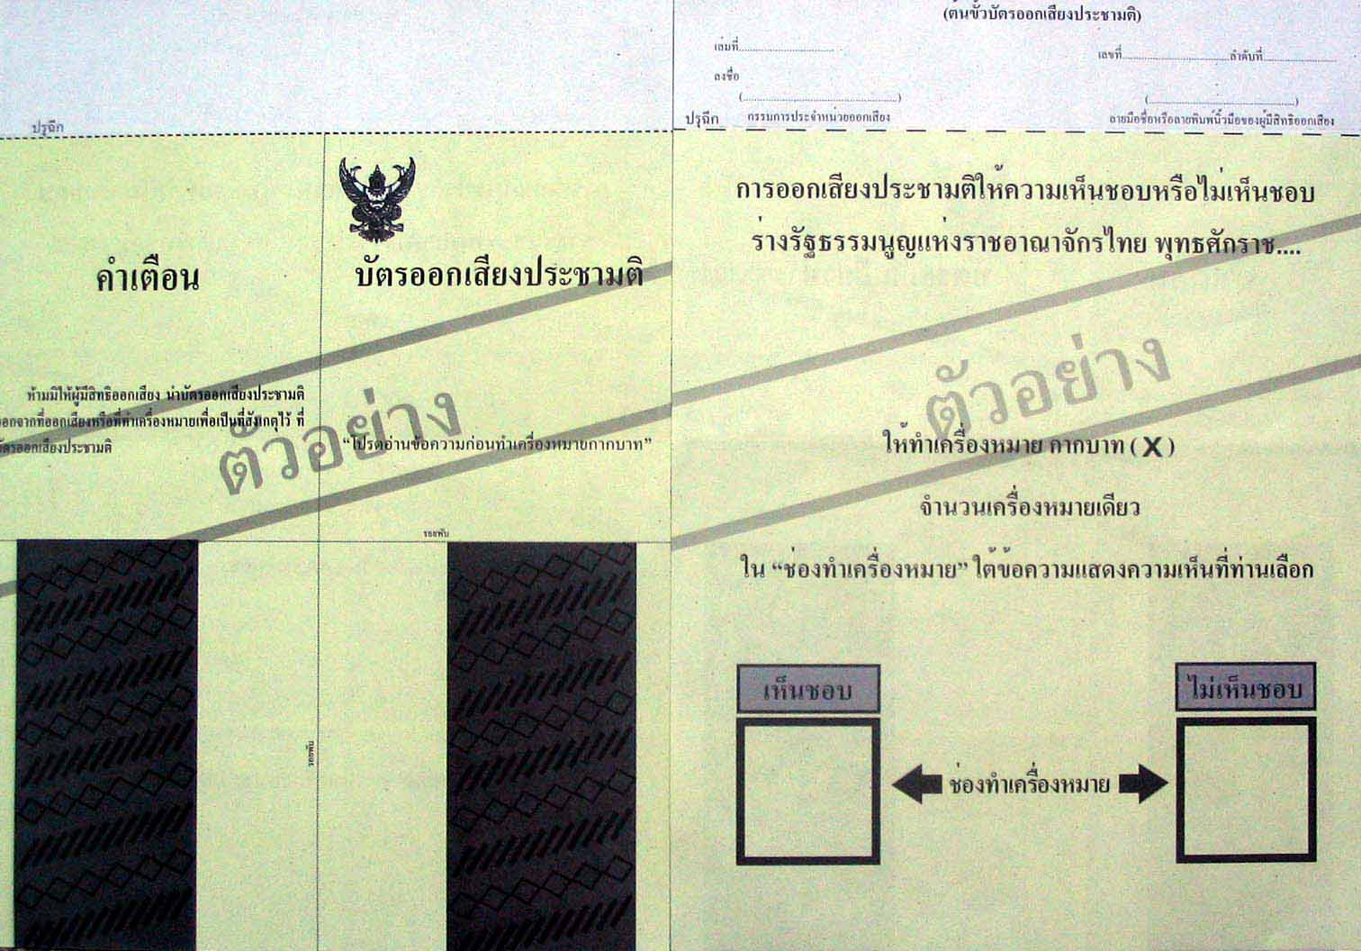

Picture 8: Front and back of the referendum ballot paper.

Opinions of the people on the referendum

Of course, I wanted to gauge the mood of people towards the referendum, without, however, being interested in conducting any survey, because the result would be known soon enough, and I was more curious about their expressed opinions than in what they would say on any externally generated items in a questionnaire. Thus, I informally asked a number of people, most of whom I have known for some time already, about their opinions regarding the referendum. Not surprisingly, the opinions given differed widely. A 71-year old Chinese-Thai shopkeeper expressed strong rejection of the Surayud government, the decision to dissolve TRT, etc. He did not want to answer my question about his voting decision directly, but said that in his heart he knew already how he would vote. Given his very critical view of the power-holders, I assumed that he would likely be in the “no-vote” camp.
When I sent my laundry for cleaning to my usual shop, I was lucky to meet the owners, because nowadays they mostly stay in Pattaya to operate a restaurant. They have been long-term enemies of the Chaisaeng family’s political domination of the municipality that is designed to prevent the development of any opposing groups. Both husband and wife wanted to see the constitution passed first, and then amended later, if necessary. They thus reflected part of the official point of view. The wife thought that Charan Pakdithanakul—the permanent secretary of the Ministry of Justice, who played an important role on the Constitution Drafting Committee—would make a good prime minister. I had already heard this opinion in Bangkok. Obviously, Charan had been seen by some as a virtuous person who would bring competence and incorruptibility to Thai state affairs. Others saw him as a naïve or ignorant anti-politician hardliner. The husband pointed out to me that Thaksin Shinawatra was corrupt and thus had to go. When I suggested that Thaksin was elected by the people, he responded that this might have been the case, but the election was bought, including the MPs. In choosing this line of thought, he followed one of the standard justifications for the coup, namely that Thaksin had owed his victory to what critics call “money politics” for which reason the election result was illegitimate. The couple’s opinions might have been “their own,” but they also reproduced a more general line of political communication in defense of the coup.
The doctor treating my bad cough said that he had not yet read the constitution. Anyway, this referendum was not actually about the content of the constitution. Rather, it was about a political fight between the anti- and the pro-Thaksin forces. He thought that, like in elections, voting was compulsory. His statement did not express an involvement in the actual questions, like with the first three respondents, but rather took an observational position. From here, one sees two warring political groups who want to make use of the voters for their respective purposes. The director of a secondary school, a long-term friend, had also adopted a more observational stance. However, it was designed to reach a decision. She wanted to hear my position and said that she did not know yet how she would vote. Until now she had listened to a number of people in order to form her own opinion. This reflected her generally cautious and detached approach to politics, while she is a lot more articulate and very active when it comes to matters of education.
When I bought my newspapers at my usual shop at the old market, a young man entered the shop and started to talk to the shopkeeper about the fact that the constitution did not stipulate Buddhism as the national religion. He acknowledged that no constitution had done so. However, this point was reason enough for him to reject the draft. A number of Buddhist temples in Chachoengsao had put up banners demanding that Buddhism be recognized in the constitution as Thailand’s national religion. The local stringer of a number of national newspapers also told me of his impression that, in the villages that he had visited, this question indeed played an important role in decision-making for a number of people.
The editor of local newspaper Dao Paetriu told me that a relative had come into her office and exclaimed, “This constitution comes from a revolt (kabot), not from the people. We cannot vote for it!” Asked whether she would cast her vote, she said, “Yes, the polling station is right behind my shop. But whether I will vote in favor or against it is another matter.” The constitution was on her desk, and she expressed her intention to make some time to read a few articles. Anyway, she had not affixed the CDA’s pro-constitution sticker that I had given to her a few days earlier. In fact, her father is in the Chaisaeng political camp, serving as a municipal councilor. Her political opinions, if any, were different from his; an often-repeated complaint was that Chachoengsao seemed to lack any capable people for filling the political positions in the province.
The female owner of the Kodak shop that used to be my source of slide films until I went digital said, “We will have to accept the draft constitution in order to get an elected prime minister again.” Similar opinions were also expressed by others. For example, a school director thought that most people would vote for the draft constitution simply because they wanted to return to normalcy. A woman working in a school thought that many people did not know much about the referendum, so many would simply stay home. Of those who would vote, most might vote in favor of the draft in order to move on to an election. This approach to the constitution referendum showed a lack of interest in the document in and of itself. Rather, it focused on the circumstances of the constitution’s production, evaluated those as negative, but saw the passing of the draft as the way to return to a non-military political environment. This position inadvertently empowered the coup group and its helpers on the CDC/CDA to realize their political goals. One is probably justified to assume that this clique-in-power significantly counted on this opinion segment for pushing their constitution through the referendum. In fact the CDA’s public relations committee had actively played on this theme at the start of the referendum campaign by putting tax-financed full-page advertisements in newspapers saying “accept the new constitution so that Thailand would have an election” (for example, Matichon, June 26, 2007, p. 19). They were only withdrawn after heavy criticism about the distorting nature of this message. After all, the interim constitution clearly stipulated that with or without the acceptance of the draft in the referendum, there would be an election.
One day, when I was walking around the old market, I met a one-time provincial councilor, Khun Somsak, whom I had known since the days of my PhD field research back in 1990. This man used to be in selling agricultural goods, but now mostly operates a small sausage factory. He has clear opinions on many things and likes to express them. Regarding the draft constitution, he said that he will accept it because money reigns supreme in Thai democracy. To the outside world, a military coup might look like a bad thing. However, he personally had in fact not lost any of his rights. Rather, the coup was necessary to prevent a network of relatives [Shinawatra] from taking absolute control of the country. That the government did not allow the opponents of the draft constitution any space to campaign for their point of view was all right because the old power clique had to be obstructed. Luckily, Thailand had its King—without him, chaos would prevail. Obviously, this sort of perspective can easily confuse those foreigners and Thais who follow a black (military coup—dictatorship—bad) and white (elections—democracy—good) worldview. This is especially so when the perspective is not voiced by a Bangkok-based elite ideologue, but by an intelligent, sincere, politically very interested, and articulate small-scale provincial businessman. As the statement shows, he was very much aware of an assumed Thai—foreigner perceptional difference. At one point, he asked, “Michael, you understand, right?” This question was not directed towards my knowledge of the Thai language, but to my understanding of Thai politics. He tried to explain these issues to me because he assumed that I had developed some feeling for the political situation in Thailand and would thus not outright condemn his view as pro-coup and anti-democracy.
One day before the referendum, in the afternoon, I went to the Bang Nam Prieow district office to observe the distribution of election material to the polling station committees. On my walk back to the bus stop at the market, I visited a couple I had known for many years. She is a nurse in the provincial hospital, while he is a teacher in a village school. They are not outspoken but rather cautious in what they say. While the wife thought that accepting the draft constitution would lead to a return of democracy, her husband disliked the way the draft was being imposed on him. He wanted to have a “no vote” box to be able to show his disagreement. Besides, until now it had not yet been proven that Thaksin really had committed any corrupt acts, and corruption was what he strongly disliked in politicians and civil servants. Another attempt at getting an opinion on the referendum from a female market vendor who has her stall at the intersection where the bus stop is located yielded an angry (but not towards me) response: “I am bored – Thai politics is in such a turmoil!” To make sure that I got what her opinion was, she repeated it. Since I had occasionally sat at her stall talking with her about this and that, it was remarkable that she had just this to say, and did not want to talk anything more about this issue.
Finally, a source in the CDA’s provincial-level sub-committee told me that even in the group of people working to publicize the draft constitution, opinions were split about whether or not they should accept the draft. Some members thought that it should be rejected because of the way it had come into existence, and in order to teach the military a lesson. The source itself, however, was in favor of the constitution, even if this was only in order to get back to a normal political situation, and not to delay the elections any further. Yet, the source strongly disliked that those in power had limited political options by dissolving the Thai Rak Thai party and by disqualifying its 111 executives. The same source also did not like the Democrats, and certainly not their candidate in 2005, Phatcharakriengchai Singhanat, who ran for the House in constituency 1, which included the municipality. Under these circumstances, the source said, there might be little electoral choice in the upcoming election. There might be an election, but the options were too narrow and too pre-determined. Moreover, the multi-member constituency system, combined with the return of the vote counting to the polling stations, might well lead to violence in terms of killed hua khanaen (vote canvassers). When I expressed doubt about this point, the source reiterated the opinion. However, we agreed that vote buying would become more necessary, while the people’s voting behavior could be more easily controlled by the village-based hua khanaen. Finally, the source also thought that bigger constituencies of course forced candidates to spend more campaign funds, not less, as envisaged by the CDA.

Besides providing a glimpse into the range of opinions held by people concerning the draft constitution and its political context, the statements related here also illustrate that the elite-sponsored cliché of “political awareness” as the solution to political problems supposedly caused by its absence among up-country voters is unrealistic. Political awareness, if anything, increases the range of political opinions. However, in the context of the state’s attempt to build samanachan (being of the same opinion), “political awareness” might denote the compliance of the people with what the establishment in Bangkok thinks is good. Yet, such compliance cannot be achieved in an open society.

The result of the referendum

For comparative purposes, here is the nation-wide result of the referendum.

Table 1: Country-wide result of the referendum (by region)

District | Registered voters | Ballots cast | Valid votes | Invalid votesª | Yes | No
Central | 15,144,307 | 8,741,488  (67.72%) | 8,589,647 | 151,815 | 5,714,973  (65.38%) | 2,874,674  (32.89%)
South | 6,268,074 | 3,717,664  (59.31%) | 3,640,389 | 77,271 | 3,214,506  (86.47%) | 425,883 (11.46%)
Northeast | 15,351,973 | 8,360,677  (54.39%) | 8,200,139 | 150,492 | 3,050,182  (36.53%) | 6,149,957  (61.67%)
North | 8,328,601 | 5,169,125  (62.06%) | 5,044,572 | 124,542 | 2,747,645  (53.15%) | 2,296,927  (44.44%)
TOTAL | 45,092,955 | 25,978,954  (57.61%) | 25,474,747 | 504,120 | 14,727,306  (56.69%) | 10,747,441  (41.37%)

ª In addition to the invalid votes, a number of voters returned their referendum ballot papers to the officials in their polling stations. Altogether, 87 voters did so.

Source: Document “The statistics of the referendum on 19th August 2007” as posted on the ECT web site.

To be sure, the win by merely four million votes was considerably less than the military coup leaders and their auxiliary bodies had hoped for. Worse still, the result confirmed that the entire Northeast and much of the North continued to follow the “old power clique,” making a mockery of the government’s declared goal of uniting the people of the country by “reconciliation.” Obviously, most voters in those two regions did not buy into the terms defined by the military-created power bloc. The result in the South—with a mere 11.5 percent of votes against the draft constitution—also confirmed why the Democrat party could aim for exacerbating Thailand’s state crisis in the hope of electoral gain by boycotting the election of April 2006. The party is so dominant in this region that it could simply prevent any non-Democrat MP candidates running without competition in the southern constituencies from gaining the required 20 percent of the valid votes.

Let us now have a look at the result in Chachoengsao province.

Table 2: Result of referendum in Chachoengsao (by district)

District | Registered voters | Ballots cast | Valid votes | Invalid votes | Yes | No
Mueang | 105,615 | 61,098  (57.85%) | 60,044 | 1,054  (1.73%) | 39,887  (66.43%) | 20,157  (33.57%)
Bang Nam Prieow | 59,047 | 34,582  (58.57%) | 34,763 | 719  (2.08%) | 22,061  (63.46%) | 12,702  (36.54%)
Bang Pakong | 60,614 | 34,626  (57.13%) | 33,919 | 707  (2.04%) | 22,381  (65.98%) | 11,538  (34.02%)
Phanom Sarakham | 57,200 | 31,371  (54.84%) | 30,802 | 569  (1.81%) | 19,668  (63.85%) | 11,134  (36.15%)
Ban Pho | 36,603 | 21,365  (58.37%) | 21,042 | 323  (1.51%) | 14,911  (70.86%) | 6,131  (29.14%)
Plaeng Yao | 27,515 | 16,560  (60.19%) | 16,260 | 300  (1.81%) | 10,611  (65.26%) | 5,649  (34.74%)
Bang Khla | 34,163 | 20,842  (61.01%) | 20,465 | 377  (1.81%) | 15,355  (75.03%) | 5,110  (24.97%)
Ratchasan | 9,323 | 5,683  (60.96%) | 5,537 | 146  (2.57%) | 3,252  (58.73%) | 2,285  (41.27%)
Sanam Chai Khet | 47,540 | 24,688  (51.93%) | 24,033 | 655  (2.65%) | 11,998  (49.92%) | 12,035  (50.08%)
Thatakiap | 29,459 | 14,601  (49.56%) | 14,216 | 385  (2.64%) | 7,582  (53.33%) | 6,634  (46.67%)
Khlong Khuean (semi district) | 10,413 | 6,262  (60.14%) | 6,141 | 121  (1.93%) | 4,521  (73.62%) | 1,620  (26.38%)
TOTAL | 477,492 | 272,578  (57.09%) | 267,222 | 5,356  (1.96%) | 172,227  (64.45%) | 94,995  (35.55%)

Source: Provincial Election Commission, Chachoengsao province

As shown in table 2, the result in Chachoengsao reflected the average result for the central region, though the average turnout was 10 points below that of the average of all central provinces. Remarkably, Sanam Chai Khet district had a majority against the draft constitution, while the result in Thatakiap district was relatively close. These districts are the poorest in Chachoengsao. The districts are partly covered by forest, and migrants from Thailand’s Northeast constitute the majority of the population. In political terms, these two districts had long been the voter base of Suchart Tancharoen, whose last political affiliation was Thai Rak Thai. However, I have no data on whether Suchart had in any way campaigned against the draft constitution or instructed a number of his hua khanaen to ask voters to cast their ballots against the document.
In his report on Sakhon Nakorn province, which voted 72.5 percent to 27.5 percent against the draft constitution, Thotsaporn Somphong identifies a clear tendency of voters in urbanized areas to have a higher proportion of acceptance than those voters who live in rural areas. However, even in urban areas, 56.3 percent of the voters rejected the draft, though this is considerably lower than the rural rejection rate of 81.3 percent. As usual, the factors said to lead to this difference between urban and rural areas are economic status, education, and the availability of information. All this is said to result in a tendency of urban voters to accept the draft—although it is not explained why, for example, more educated and informed voters should not reject the draft rather than accept it. Indeed, it appears that the majority of voters in areas populated by higher-level teaching staff also rejected the constitution, while ajarn Thotsaporn hypothesizes that the majority of social science lecturers accepted the draft because they knew about Thaksin Shinawatra’s dark side.
I cannot offer a similarly detailed analysis of the referendum data as ajarn Thotsaporn does. However, regarding the urban-rural difference, I can confirm that the tendency pointed out in his report does seem to exist in Chachoengsao as well. Most urbanized areas (small and large municipalities) returned significantly higher rates of acceptance than the average in their districts and the provincial average. This is also true for Sanam Chai Khet district, the only one where there was a slight majority against the draft constitution. However, two of the district’s four sub-districts (assumed to be rural areas) also had majorities in favor of the draft, although not as high as in the municipality. In Amphoe Mueang (the most developed main district, which includes the provincial capital and the administrative center), the average was also higher in eight of its 18 sub-districts (between 71-76 percent), while the remaining sub-districts were below average (52-63 percent).
Without good access to locally-based information—this concerns municipalities, districts, sub-districts, villages, and polling stations—it is impossible to explain certain differences in the outcome of the referendum. For example, why did two tambon municipalities in Phanom Sarakham district accept the draft with 75.5 and 72.2 percent, while the third tambon municipality only reached 61 percent? Similarly, in Bang Pakong district, two municipalities had majorities of 79.2 and 75.4 percent, while the third only had a majority of 60.3 percent. In Bang Nam Prieow district, three of the four municipalities had acceptance rates of well below the district and the provincial averages, with one municipality, Sala Daeng, even rejecting the draft with a 51.6 to 48.4 percent majority. In fact, the sub-district of Sala Daeng also rejected the draft at about the same proportion. As a whole, the municipality Bang Kanak had a narrow majority in favor of the draft, but one of its two polling stations had a majority against it.
In some polling stations of sub-districts Monthong and Ton Chimpli of Bang Nam Prioew, there were acceptance rates of far above the district and provincial averages (73-88 percent in the former, and 83-92 percent in the latter tambon). In the same district, five polling stations in Bueng Nam Rak sub-district returned acceptance rates of between 75 and 97 percent, while the remaining three polling stations had majorities against the draft of 53, 69, and 82 percent. Of course, one could assume that individual voters residing in neighboring villages had independently built their opinions about the draft constitution and thus produced these opposite aggregations purely accidentally. Or one might try to identify factors that correlate with these differences in opinions, such as differences in occupation, religion, education, access to the mass media, and different preferences for political parties and their local candidates, including voting behavior in past elections. However, neither approach seems to be too realistic. Since polling stations are village-based, it rather suggests, as ajarn Thotsaporn also does for Sakorn Nakorn, that such differences might best be explained by different actions taken by sub-district headmen (kamnan), village headmen (phu yai ban), and members of the Tambon Administrative Organization in relation to pushing for a yes or no vote amongst their fellow villagers. The role of these office holders in the referendum would then have been similar to their usual role as hua khanaen (vote canvassers) for candidates in elections.
As for Bueng Nam Rak, it is also interesting that of those polling stations that returned majorities in favor of the constitution (nos. 1, 2, 6-7, covering villages nos. 1, 2 and 9-15), four were located in schools attached to mosques, while one more was in a special school. The majorities against the draft occurred in polling stations 3-5 (covering villages nos. 3-8), of which two were located in the premises of private individuals (one farmer’s house and one garage) and one in a school attached to a Buddhist temple. Thus, it would be worthwhile to know whether socio-political networks in adjacent villages had an impact on the people’s voting behavior. Even more important, there are reasons to assume that Buddhist voters in Bang Nam Prioew district tended to reject the draft because it did not stipulate that Buddhism would be the official state religion. In tambon Monthong, there was a similar picture. The draft was rejected in a polling station located at a temple and at one located in the house of the village headman. However, in one wat-based polling station, there was an above average acceptance of the draft. This is another case of the need for more details. One can assume that not all Buddhist temples took a strong stance in favor of Buddhism as a state religion. In tambon Ton Chimpli, which had 19 polling stations, the below-average acceptance rate also manifest in polling stations attached to Buddhist temples and the house of a village headman. At the same time, polling stations in Muslim schools returned acceptance rates far above the average (similar to Monthong). There was also one polling station in a wat that voted 83.8 percent for the draft.
The local stringer of a number of national newspapers told me that, from his talks with villagers, the issue of Buddhism not having been declared the official state religion should have had an impact on voting behavior. Interestingly, during the hearings on the draft constitution in Bang Nam Prieow district, the participants in their great majority were against making Buddhism the state religion. Unfortunately, I could not figure out the religious distribution of the participants.
As these few examples demonstrate, aggregations at the provincial, district, and even the sub-district/municipality levels potentially hide very interesting details of voting behavior that indicate telling differences in local political and even religious relationships. However, as pointed out already, finding out more about these issues would have required systematic data collection in the municipalities and at the district, sub-district, and village levels. This was beyond what I could do in this more limited research project.

Conclusion

After the new constitution went into effect, the attention turned to the election scheduled for December 23, 2007, and Thailand’s immediate political future. A number of commentators argued that this new constitution aimed at delimiting the voters’ power by fragmenting the political party structure and forcing a number of parties to establish weak, conflict-ridden, and probably short-lived coalition governments, thereby rendering elected government and thus the constitutionally stipulated sovereignty of the people ineffective, while by default strengthening special interest groups, such as the civil bureaucracy as well as the military. The military’s power seems to have been increased by the passing of the controversial Internal Security Act and the Act Concerning the Organization of the Ministry of Defense, which largely deprives the prime minister of his previous power to transfer generals in the three armed forces, by the National Legislative Assembly. The removal of Thaksin and TRT from the formal political equation might have an even bigger impact on the fragmentation of parliamentary and governmental power than what is written in the constitution.
Indeed, the election has produced a coalition government of six political parties, led by the successor of the TRT, People’s Power party (PPP). Its leader, the self-confessed “nominee” of former prime minister Thaksin Shinawatra, Samak Sundaravej, was elected prime minister. While there was a clear and strong hierarchy between the prime minister and his cabinet members in governments headed by Thaksin, the present cabinet did not originate from the formal or informal powers of Samak, because he is essentially an outsider in PPP. It is rather underpinned by the individual coalition parties, their internal factions, and the informal powers still wielded by the “politically disqualified” 111 former members of TRT’s executive board. Moreover, beneath this level, Thaksin seem to exert significant influence from his exile abroad and probably through his wife, Pojaman, who has returned to Thailand already. It is clear that amendments to the military-initiated constitution of 2007 are on the agenda of the new government, as is an amnesty for the 111 former TRT executives, including Thaksin. However, at the time of writing, it seemed that these two issues did not have immediate priority.
Therefore, when it is said that the election of December 23, 2007 returned democracy to Thailand, this might not be an entirely accurate assessment. Rather, what Thailand has achieved is an elected government created on the basis of the coup-makers’ and related interests’ constitutional stipulations, and party-political factors. The people’s genuinely sovereign act of voting might by comparison be of more limited significance. This also applies to the power-play by all the involved elected and non-elected groupings after the election in their struggle to participate in one way or another in governing the country and protecting their interests. If this is what the CDA meant by “non-monopolistic politics,” then it might even achieve its aim. But one can reasonably doubt that the outcome will be more democratic and participatory politics, more effective government, and better results for the people and the country.

Endnotes ? Visiting scholar, Faculty of Political Science, Chulalongkorn University, Thailand; senior researcher, Southeast Asian Studies, University of Passau, Germany.
My field research in Chachoengsao lasted from July 18 to August 24, 2007. I was stationed in the provincial capital in order to observe the activities of the local branch of the Constitution Drafting Assembly and the provincial election commission, as well as any anti-constitution activities. Being largely confined to the capital by having no means of independent transportation severely limited my ability to collect data in the province’s districts. During the period of field research, I used the possibilities of the Internet and digital photography to report directly “from the field” to interested colleagues, students and others by posting five texts of about 5,000 words, plus 33 pictures, on the blog New Mandala. The ability to combine textual and visual information especially appealed to me (although, admittedly, I am not a good photographer, with further limitations imposed by my use of a borrowed Canon Power Shot A 70). New Mandala is located at the Research School of Pacific and Asian Studies, Australian National University (http://rspas.anu.edu.au/ rmap/newmandala/). Its bloggers are Andrew Walker and Nicholas Farrelly. I thank Nich for editing and arranging my posts. All this was an interesting experience of academic globalization in practice—putting together texts and photos in Chachoengsao and sending them to Nich in Oxford (UK), who would then place them on a web site in Australia, to be read by an audience in Australia, Thailand, Europe and the US. I wish more researchers in Southeast Asian Studies would make use of these possibilities, and thus shorten the time for making intial information about their findings available to others interested in their fields of study.
On the public hearings in Chachoengsao, see my earlier paper, “Public Hearings on Thailand’s Draft Constitution: Impressions from Chachoengsao Province.” KPI Thai Politics Up-date. No. 3 (August 14, 2007).
แผนปฏิบัติภารกิจการเผยแพร่ร่างรัฐธรรมนูญ เพื่อการลงประชามติ (ช่วงที่ 3). Document of the provincial CDA.
The civil servant supervising a TAO’s employees is called palat TAO.
According to a participant, this was merely an occasion to take pictures of the provincial committee members, who had received an award from the national-level CDA for their work. The content of the constitution was not touched upon.
See the meeting agenda วาระการประชุมหัวหน้าส่วนราชการ รัฐวิสาหกิจ และกำนัน ผู้ใหญ่บ้าน ฯลฯ สมาชิกสภาท้องถิ่น ครั้งที่ 8/2550 เมื่อวันพฤหัสบดีที่ 2 สิงหาคม 2550 เลา 10.00 น. ณ หอประชุมอำเภอบางคล้า, p. 3. As can be seen from this document, the meeting was to start at 1000 hours, not at 0900 hours, as was given in the action plan.
“การลงประชามติครั้งแรกของประเทศไทย.” กรุงเทพฯ: สำนักงานคณะกรรมการการเลือกตั้ง.
“สาระสำคัญ ของ ร่างรัฐธรรมนูญแห่งราชอาณาจักรไทย พุทธศักราช ๒๕๕๐: 19 สิงหาคม ร่วมลงประชามติ.” สภาร่างรัฐธรรมนูญ.
Thai Rath (July 30, 2007) had headlined its editorial, “[Providing transportation is] not against the law, but should not [be done.]”
These Rajaphat Universities are not to be confused with the regular universities. “Rajaphat University” merely is a different label for what was previously called “Teachers’ College.”
The Royal Institute was sufficiently annoyed by this often-heard negligent Thai that it issued an official declaration according to which the correct translation of “national agenda” was “rabiap wara haeng chart” (printed in Matichon, October 30, 2007, p. 7), because “wara” had the same meaning as “khrang” (time, like in “two times” or “at that time”). However, the institute somehow overlooked that it makes little sense to speak of “a” national agenda in this context, because an agenda is an ordered sequence of items, be it as a meeting agenda or a more symbolic national agenda. Therefore, something like a referendum cannot be an agenda but merely an item that is placed at the top of or high or low on the agenda. This matter of meaning is further confused by the fact that meeting agendas in Thai are called “rabiap wara kanprachum,” while each individual item on this agenda is also often called “agenda”, for example “agenda no. 1” (rabiap wara thi 1).
Obviously, this statement needs to be qualified when applied to the election of April 2006, which was boycotted by TRT’s main competitors, the Democrat and the Chart Thai parties, and later nullified, on the urging of the King, by a narrow majority of 8 to 6 in the Constitutional Court.
The upper-most sticker shows the CDA’s main symbol—a traffic light, with the suggestion that a big green light should be given to the draft constitution. Note that the background color is yellow, suggesting that CDA and ECT were loyal to the King in performing the referendum and pushing for a “yes” vote, as far as the CDA was concerned. This contrasted sharply with the red color used by the anti-coup TRT (see pictures 6 and 7 below). It also lists the four main selling points of the draft. The other two stickers were produced by the ECT and distributed by the PEC.
Constitution Drafting Committee, Constitution Drafting Assembly. 2007. “Highlights of The Draft Constitution B.E. …” Prepared for dissemination by CDC Spokesmen Team, April 19, 2007. The original Thai-language version was printed in, for example, Post Today (April 18, 2007:A4) and Matichon (April 19, 2007:2, 11). Post Today, in their subtitle, suggested that the question now was to decide whether this draft was progressive or regressive, as compared to the constitution of 1997. Matichon’s headline read, “Showing the selling points of the constitution: reducing monopolization, building balance of power.” An explanation of these four points also constituted the main content of the CDA’s leaflet that was widely distributed in the run-up to the referendum: “สาระสำคัญ ของ ร่างรัฐธรรมนูญแห่งราชอาณาจักรไทย พุทธศักราช ๒๕๕๐: 19 สิงหาคม ร่วมลงประชามติ.”
For a recent work on education reform see Michelle Tan. 2007. “The Politics of the Decentralisation of Basic Education in Thailand.” Ph.D. thesis, University of Leeds, School of Politics and International Studies (POLIS).
In my paper on public hearings on the draft constitution, I have briefly described the importance participants attached to the issue of education, including that education should “really” be free, and up to a good standard (Michael H. Nelson. 2007. “Public Hearings on Thailand’s Draft Constitution: Impressions from Chachoengsao Province.” KPI Thai Politics Up-date. No. 3, August 14, 2007, pp. 11-13.). One might wonder whether the latter instance does not actually contradict Section 30 of the new constitution, which prohibits discrimination based on a number of criteria, among them “economic status.”
The proportion of the elderly in Thailand’s population has increased substantially over the years, accompanied by a dramatic decrease of the average number of children per woman. Thus, this issue has become a serious policy problem.
This comparison of the CDA with Thaksin also points to a systematic constitutional problem concerning the section on state policies. Section 3 of the constitution stipulates that “The sovereign power belongs to the Thai people.” Elected governments realize this power by devising and implementing policies. The CDA was put in place by a military coup and acted like an unelected government whose material policy decisions (which are different in nature from decisions concerning the rules of the game, i.e., the genuinely constitutional subject matter) bind any subsequent elected executive, thereby subverting the peoples’ sovereignty and compromising the significance of elections.
Of course, bringing a case before the Constitution Court is more complicated than this statement suggests.
According to the provincial CDA’s campaign walk plan แผนการเดินทางรณรงค์การออกเสียงประชามติ. All walks started at 0900 hours.
While walking around, I heard the school director announce through the loudspeaker system that, today, there was also a German researcher who wanted to observe the event. I had known this director since the election of 2005, at which time he doubled as director of election constituency two. I had attended a number of meetings of the constituency committee, and the vote counting, for which his school served as central vote-counting place. At midnight of the second night of counting, the committee and I waited for the final tabulation of the election results in his office, everyone being ready to drop.
In an exaggeration of new-public management approaches, a second group of students immediately followed the first one to ask the people how they evaluated the activity that they had just witnessed. On a scale from 5 (very satisfied) to 1 (very dissatisfied), the respondents were ask to say what degree of information they had received from the leaflets (which they had no time to read yet); how appropriate the route of the campaign walk was (since there is only one main road at this market, there were no other options anyway); how appropriate the time of the walk was; how satisfied they were with the walk; and how satisfied they were with this referendum (probably meaning with the fact that they were asked by the military rulers to approve their draft constitution). Of course, a space was also dedicated for additional suggestions the respondents might have had. See the form แบบประเมินความพึงพอใจในการรณรงค์ให้ประชาชนไปร่วมออกเสียงประชามติ อำเภอบางน้ำเปรี้ยว วันที่ 15 สิงหาคม พ.ศ. 2550. Such walks have long been used by the PEC around election time.
I am not aware of any academic attempt to determine the actual power of this reference to the color yellow, and the King, on the motivation of voters to cast their votes in this or that direction. One might assume that this use of color, first of all, operated as an identity marker for the bureaucratic sector. But why does this sector need this sort of identity?
When I arrived at the stage, it was already full, and hundreds of students, led by teachers, had gathered on the square in front of sala thai. A helpful lady from the provincial chamber of commerce—the office of which served as the provincial committee’s secretariat—asked me, “How did you know [this event would happen]?” Indeed, I almost missed it. Although I had the provincial CDA’s schedule, I did not know that the campaign rallies by all participating schools would start together from sala thai. Thus, I first went to one of the schools, and then to the office of a local newspaper. There, I was told that somebody had already gone to take pictures of the event at sala thai. So, I rushed there, and luckily arrived in time. Shortly after my arrival, I heard Khun Somnuek announce on stage, “Ajarn Michael has also arrived already.” The deputy chairperson of the Democrat party’s provincial branch, and MP candidate in 2005 and 2007, Chalee Charoensuk, joined the state and CDA representatives on stage, wearing a yellow jacket, and taking pictures of the provincial governor while he delivered his opening speech.
This is my translation of the prepared text that I obtained in the secretariat of the governor: คำกล่าวประธาน การจัดงาน “เดินรณรงค์เผยแพร่และประชาสัมพันธ์สาระสำคัญร่างรัฐธรรมนูญและการไปลงประชามติ” วันศุกร์ที่ 17 สิงหาคม 2550 เวลา 09.00 น. ณ ศาลาไทยหน้าศาลากลางจังหวัดฉะเชิงเทรา.
At first, the editor of Dao Paetriu, an old friend of mine, had not noticed that what she was about to put in her paper was not neutral information about the referendum, but rather the CDA’s promotional material. I had earlier given her TRT’s anti-constitution brochure, so I then asked her whether she would also consider printing extracts of it to make the campaign equal. The look she gave me for an answer indicated that she thought that my question was not reasonable. Dao Paetriu has been published fortnightly for the past 29 years. Its print-run is 3,000 copies. Its publishing schedule is synchronized with the fortnightly lottery draws. A banner at the top claims that it is the “mouth and voice of the people.” However, it has no active reporting of events in Chachoengsao. Below the masthead, we also read “A newspaper for Nation, Religion, Monarchy.” Neither the first nor the second “mission statement” have been used to guide the paper’s publishing activities.
Whenever there has been a military coup, the MoI seems to have felt that the time was right to implement a village-based democracy promotion project. Thus, the “democracy volunteers” of 2006/2007 were preceded by the “four democracy musketeers” as part of the ministry’s “project to promote democracy at the village level” (khrongkan phoeiphrae prachathipattai radap muban), which was implemented after the 1991 coup by the so-called National Peace Keeping Council led by Suchinda Kraprayoon. I reported on that project in Michael H. Nelson. 1998. Central Authority and Local Democratization in Thailand: A Case Study from Chachoengsao Province. Bangkok: White Lotus Press, chapter six. For information on this latest project see, for example, กระทรวงมหาดไทย. 2550. คู่มือประกอบการฝึกอบรมวิทยากรแม่ไก่ โครงการพัฒนาการเมืองการปกครองในระบอบประชาธิปไตยอันมีพระมหากษัตริย์ทรงเป็นประมุข ประจำปี ๒๕๕๐. กรุงเทพฯ [Manual for the training of mother hen instructors, project to develop politics and government in the democratic system that has the king as head of state]. Note that the 1991 project merely referred to democracy without the addition of the king as head of state. According to this manual (p. 75), the first duty of the democracy volunteers is to “create the correct knowledge and understanding about politics and government in the democratic system that has the king as head of state with the people at the grassroots level.” One is probably not mistaken to think that casting one’s vote for TRT candidates and Thaksin was seen as reflecting an “incorrect” understanding of such MoI-defined democracy.
Trakul is a former civil servant with the MoI and a specialist in the local government area. Prapas is widely known for his book on the Assembly of the Poor, ประภาส ปิ่นตบแต่ง 2541. การเมืองบนท้องถนน: 99 วันสมัชชาคนจน และประวัตศาสตร์การเดิน ขบวน ชุมนุมประท้วงในสังคมไทย. กรุงเทพฯ: ศูนย์วิจัยและผลิตตำรา มหาวิทยาลัยเกริก [“Street-level politics: 99 days of the Forum of the Poor, and a history of demonstrations and protest rallies in Thai society”].
“คู่มือคนไทยเพื่อเข้าใจร่างรัฐธรรมนูญปี 50 [Manual for the Thais to understand the draft constitution of 2007].” [กรุงเทพฯ:] โครงการส่งเสริมการเรียนรู้และการมีส่วนร่วมทางการเมือง คณะรัฐศาสตร์ จุฬาลงกรณ์มหาวิทยาลัย, [2007]. As can be seen from this setting—having one lecturer from the faculty speaking against the draft constitution, while a pro-constitution brochure produced by the same faculty is distributed—academia and its institutions were split on how to deal with the coup and the constitution. The faculty’s dean, Charas Suwanmala, was strongly in favor of coup and constitution. As a member of the CDA, he took active part in its public relations sub-committee. As part of the Surayud government’s public relations “war room,” he participated in coup-defending seminars at the School of African and Oriental Studies (SOAS), the Friedrich Ebert Foundation in Berlin, and the Australian National University. On the other hand, his colleague at the same faculty, Giles Ungpakorn, well-known for his socialist and anti-coup activism, published the book A Coup for the Rich: Thailand’s Political Crisis. Bangkok: Workers Democracy Publishing, 2007. The faculty, as part of the same project, had already printed a booklet called “Democracy can really be used: Manual for the Thais” (ประชาธิปไตยใช้ได้จริงๆ: คู่มือคนไทย. [กรุงเทพฯ:] โครงการส่งเสริมการเรียนรู้และการมีส่วนร่วมทางการเมือง คณะรัฐศาสตร์ จุฬาลงกรณ์มหาวิทยาลัย, [2007]). Part of it consisted of a crude attack on deposed prime minister Thaksin Shinawatra. The last page, in big letters, read, “Every Thai participates in building democracy”—yes, perhaps, but on the terms of the Bangkok-based elite. The academic factionalism resulting from different evaluations of the military coup, and especially the willingness of so many academics to support and actively help the coup makers, still needs to be analyzed. For some Thai-language material see ภิญโญ ไตรสุริยธรรมา บรรณาธิการ. 2550. ปฏิวัติ 2549 [The revolution of 2006]. กรุงเทพฯ: สำนักพิมพ์ openbooks. October No. 6, and ธนาพล อิ๋วสกุล บรรณาธิการ. 2550. รัฐประหาร 19 กันยา: รัฐประหารเพื่อระบอบปรัชาธิปดตยอันมีพระมหากษัตริย์ทรงเป็นประมุข [The military coup of 19 September [2006]: A coup for the system of democracy which has the King as head of state]. กรุงเทพมหานคร: ฟ้าเดียวกัน.
“ทำไมควรไปลงมติ ‘ไม่รับ’ ร่างรัฐธรรมนูญ 50.” [กรุงเทพฯ:] ไทยรักไทย, July 2007 (16 pp.) [Why you should vote “no” in the referendum on the draft constitution 07].
My statements concerning anti-coup activities are limited to open actions in the area of Chachoengsao’s main district (amphoe mueang), and especially the municipality. There might have been “underground” campaign processes that did not come to my attention. Furthermore, I was stationed in the municipality, because I also had to collect data on the provincial CDA and the PEC, both of which had their offices in this area. The duration of my fieldwork, the fact that I was working on my own, limited funds, and the unfortunate fact that I have neither driving license nor car made it impossible to check whether Chachoengsao’s other political groups, besides the Chaisaengs, had campaigned against the constitution. This primarily concerns the groups around Itthi Sirilatthayakorn in Bang Nam Prieow, Khlong Khuen, Bang Khla, Ratchasan, and in parts of Phanom Sarakham districts, and of Suchart Tancharoen in other parts of Phanom Sarakham, Sanam Chai Khet, and Thatakiap districts. Both Itthi and Suchart had been TRT MPs. Sanam Chai Khet was the only district with more votes against the constitution than in favor of it, while the outcome in Thatakiap was comparatively close (see the table below).
“ไม่รับรัฐธรรมนูญ ก็ต้องมีการเลือกตั้ง และยังได้ประชาธิปไตยเต็มใบ.” [กรุงเทพฯ:] ไทยรักไทย, August 2007 [Even if the constitution is rejected, there must be an election and we will get full democracy].
This anonymous document was obviously distributed by mail in great numbers in many parts of Thailand, according to newspaper reports at the time. A few thousands of envelopes were confiscated in post offices. One wonders what the legal basis of this act could have been. The headline on the first page reads “อยากเลือกตั้งเร็ว ต้องคว่ำรัฐธรรมนูญ 2550” [If you want to see elections soon, then you must topple the 2007 constitution”].
Thitima Chaisaeng, before she ran for parliament, used to be the chairperson of the board of this education district. Both the previous director of this education district office and his successor are known to be members of the Chaisaeng’s informal political clique, what I have called phuak in an earlier paper; see Michael H. Nelson. 2005. “Analyzing Provincial Political Structures in Thailand: phuak, trakun, and hua khanaen.” Hong Kong: Southeast Asia Research Centre, City University of Hong Kong (SEARC Working Paper Series, No. 79). If a researcher undertook a political analysis of the personnel structure of these education districts (khet phuenthi kansueksa), he or she would probably find that many of them have become politicized by provincial-based informal political groups. One reason is that these districts control the teachers in that area, and can thus be used both for patronage activities by politicians (lobbying the ministry to put people close to them in the position of school administrators) and as a pool of potential vote canvassers (hua khanaen) in elections.
This promotional activity of the provincial CDA was also listed in its action plan mentioned above.
A plastic-sealed A-4 note was affixed to the gate saying “When you enter the compound at night, please shut the gate so that the dog might not get out and disturb the neighbors.” I got into the compound to look whether somebody was in the office already, but it was still closed. Thus, I left the place, closing the gate. But when I turned around after a few meters, I saw their dog standing on the road again. It knew how to squeeze itself through if one had not tightly closed the gate. During the time I had wandered around in the compound, it had merely looked at me with some curiosity, but did not bark even once.
ร่วมลงมติไม่เห็นชอบ ร่างรัฐธรรมนูญ 2550 19 สิงหาคม 2550: ไม่เห็นชอบร่างรัฐธรรมนูญ 50 ไม่เห็นชอบรัฐประหาร [Join the vote against the draft constitution of 2007 on 19 August 2007: disapprove of the draft constitution 07 – disapprove of the military coup].
Of the 393 voters, 312 approved the draft constitution, while only 77 rejected it; there were also four invalid ballots. In the election three months later, the turnout in this polling station was 484. Wuthiphong and Thitima of the People’s Power party (PPP) prevailed with 224 and 203 votes, respectively, over the Democrats’ Chatchawal (174) and Chavalit (168). However, the Democrats clearly beat PPP on the proportional list with 276 to 135 votes.
It should be noted, however, that it is widely assumed that the previous ECT, led by Wassana Phoemlap, had significantly weakened both the national and the provincial level administrations by accepting hundreds of staff members, in particular policemen working in the investigation sections, on the basis of lobbying (wing ten) rather than competitive examinations and capability. Moreover, many local policemen seem to have been transferred to work in the provincial offices. Besides having had little experience in investigation work, many of them—as is the case with many policemen working at tambon, district, and provincial levels—were probably connected to politicians in that area. Obviously, this would make it difficult for them to impartially investigate violations of the election law, such as vote buying. It is thus hardly surprising that talk of vote buying is rife, while concrete cases with subsequent punishments are comparatively rare. In a rather strange act, the ECT added close to one thousand new staff members, mainly to the PEC offices, just before the election of February 2005. This was roughly a doubling of the previous number. Obviously, those new staff members were of very little use in that election, simply because they had no prior knowledge or experience of electoral work. More importantly, it was not clear at all why the ECT had to increase its number of staff in this extraordinary way. It seems that there is a considerable number of employees at the national and provincial offices of the ECT who might not agree with putting Wassana and his two colleagues into prison for the reasons they were officially sentenced, but are satisfied that they were sentenced so as to pay for all the bad deeds they supposedly had committed while in office (somnamna—serves them right). It is remarkable that the sentencing of the ECT did not cause a public uproar by the ECT and PECs, including their offices. This would certainly have been the case if they had been perceived as three untouchably good election commissioners who were grossly mistreated by the court.
คำสั่งคณะกรรมการการเลือกตั้ง ที่ ๑๑๒/๒๕๕๐ เรื่อง แต่งตั้งคณะกรรมการการเลือกตั้งประจำจังหวัดฉะเชิงเทรา [Order No. 112/2007 concerning the appointment of the election commission of Chachoengsao province, dated July 3, 2007.]
แผนการดำเนินจัดการออกเสียงประชามติ จังหวัดฉะเชิงเทรา โสธร 4. สำนักงานคณะกรรมการการเลือกตั้ง ประจำจังหวัดฉะเชิงเทรา [Plans for managing the voting in the referendum, Chachoengsao province, Sothorn 4].
สรุปข้อมูล การเตรียมการออกเสียงประชามติ จังหวัดฉะเชิงเทรา ปี 2550. สำนักงานคณะกรรมการการเลือกตั้ง ประจำจังหวัดฉะเชิงเทรา [Data summary on the preparation of the voting in the referendum].
They had rented the place from a person who obviously had connections with another restaurant. When Chinese tour groups started visiting their place, the owner came to see them and told them in no uncertain terms that they must not accept any Chinese groups, because that was the business of the restaurant he was connected to. Since the law (and especially its enforcement agency, the police) does not help much in such sort of extortion, they had no choice but to comply, although it badly hurt their business, and they had not been told in advance of this condition.
A picture of a small card which Khun Somsak had used in his election campaign for the provincial council in 1990 can be found in the printed version of my thesis, Central Authority and Local Democratization in Thailand: A Case Study from Chachoengsao Province. Bangkok: White Lotus, 1998, p. 188.
Note that the source did not see the dissolution of TRT as a legal issue, but rather as a political one.
The Democrats, and partly the Chart Thai party in Suphanburi, could play this game of obstruction endlessly, because neither the constitution nor the election law had any provision about how to end it. The lesson learned from this appears in article 88 of the new Election Act that limits new elections to two rounds. In the second round, the limit of 20 percent of the votes does not apply.
Results as broken down by tambon and municipalities can be found in the result announcements issued by the respective district-level referendum subcommittees, using the ECT’s form Oo.So. 20 (อ.ส. ๒๐).
Turnout in the general election of 2001 was 68.7 percent. In 2005, this figure jumped to 76.4 percent, probably as a result of Thaksin’s popularity after he had governed Thailand for four years. As expected, the politically less charged Senate election of 2006 saw a drop to 62.5 percent.
ทศพล สมพงษ์. 2007. “พฤติกรรมการลงประชามติร่างรัฐธรรมนูญ พ.ศ. 2550: กรณีการออกเสียงลงประชามติในจังหวัดสกลนคร.” [Voting behavior in the referendum on the draft constitution of 2007: The case of the referendum vote in Sakorn Nakorn province] เอกสารประกอบ (เพิ่มเติม) การสัมมนาการเมืองการปกครองไทย ครั้งที่ 2 Thai Politics Forum 2007. ระหว่างวันที่ 3-4 ธันวาคม 2550, pp. 8-17.
The data mentioned in this section are derived from the ECT form Oo.So. 20 (อ.ส. ๒๐), which the district offices had to use for reporting the referendum results to the PEC. The results are divided by tambon and municipalities. The form from Bang Nam Prioew also gives the figures for the individual polling stations in the tambons and municipalities.
About half of the population living in the district of Bang Nam Prioew are of Malay origin and are thus Muslims. Reportedly, they are the descendants of war captives resettled there by an earlier Siamese king. As a result, the district has more mosques than Buddhist temples.
สรุปข้อมูล การเตรียมการออกเสียงประชามติ จังหวัดฉะเชิงเทรา ปี 2550. สำนักงานคณะกรรมการการเลือกตั้ง ประจำจังหวัดฉะเชิงเทรา [Data summary on the preparation of the voting in the referendum], p. 43f.
Michael H. Nelson. 2007. “Public Hearings on Thailand’s Draft Constitution: Impressions from Chachoengsao Province.” KPI Thai Politics Up-date. No. 3 (August 14, 2007), p. 11.
The Thai-language constitution can be downloaded, for example, from the ECT’s website at http://www.ect.go.th/thai/aw/law.html. The constitution is also available in two English-language translations. The first was prepared by IFES and the political section and public diplomacy office of the US embassy in Bangkok. It can be downloaded from, for example, the ECT’s web site at http://www.ect.th/english/upcoming.html. However, it is advisable to use this version only in conjunction with the Thai-language original, because the translation contains a number of errors. It is probably a better option to use the translation prepared by the foreign law bureau of the Thai Council of State. This version can be downloaded from the web site of the Asian Legal Information Institute at http://www.asianlii.org/th/ legis/const/2007/1.html.

